Chapter 5 General Building Heights and Areas
CALIFORNIA BUILDING CODE — MATRIX ADOPTION TABLE
CHAPTER 5 — GENERAL BUILDING HEIGHTS AND AREAS
(Matrix Adoption Tables are nonregulatory, intended only as an aid to the code user.
See Chapter 1 for state agency authority and building applications.)
Adopting Agency | BSC | BSC—  CG | SFM | HCD |  |  | DSA |  |  | OSHPD |  |  |  |  |  |  | BSCC | DPH | AGR | DWR | CEC | CA | SL | SLC
 |  |  |  | 1 | 2 | 1/AC | AC | SS | SS/CC | 1 | 1R | 2 | 3 | 4 | 5 | 6
Adopt entire chapter | X |  |  |  |  |  |  | X | X | X | X | X | X | X | X | X
Adopt entire chapter as  amended (amended  sections listed below) |  |  | X | X | X
Adopt only those sections
that are listed below
Chapter / Section
503.1 |  |  | X | X
Figure 5-1 |  |  | X
Table 504.3 |  |  | X
Table 504.4 |  |  | X
Table 506.2 |  |  | X
506.2.1 |  |  | X
506.2.2 |  |  | X
508.2.4 |  |  | X
508.3.3 |  |  | X
Table 508.4 |  |  | X
508.5 |  |  |  | X | X
508.5, Item 2 |  |  |  | † | †
508.5.3, Exception |  |  |  | X | X
508.5.7 |  |  | X
508.5.8, Exception |  |  |  | X | X
508.5.9 |  |  |  |  |  | X | X
508.5.10 |  |  |  | X | X
508.5.11 |  |  |  |  |  | X
Table 509.1 |  |  | X
509.3 |  |  | X
The state agency does not adopt sections identified with the following symbol:†
The Office of the State Fire Marshal's adoption of this chapter or individual sections is applicable to structures regulated by other state agencies pursuant to Section 1.11.
User notes:
About this chapter: Chapter 5 establishes the limits to which a building can be built. Building height, number of stories and building area are specified in this chapter. Chapter 5 must be used in conjunction with the occupancies established in Chapter 3 and the types of construction established in Chapter 6. This chapter also specifies the impact that mezzanines, accessory occupancies and mixed occupancies have on the overall size of a building.
ICC code development note: Code change proposals to sections preceded by the designation [F] or [BE] will be considered by a code development committee meeting during the 2024 (Group A) Code Development Cycle. All other code change proposals will be considered by a code development committee meeting during the 2025 (Group B) Code Development Cycle.
Section 501 General
501.1 Scope
The provisions of this chapter control the height and area of structures hereafter erected and additions to existing structures.
Section 502 Building Address
[F] 502.1 Address Identification
Diagram
New and existing buildings shall be provided with approved address identification. The address identification shall be legible and placed in a position that is visible from the street or road fronting the property. Address identification characters shall contrast with their background. Address numbers shall be Arabic numbers or alphabetical letters. Numbers shall not be spelled out. Each character shall be a minimum of 4 inches (102 mm) high with a minimum stroke width of ¹/₂ inch (12.7 mm). Where required by the fire code official, address identification shall be provided in additional approved locations to facilitate emergency response. Where access is by means of a private road and the building address cannot be viewed from the public way, a monument, pole or other approved sign or means shall be used to identify the structure. Address identification shall be maintained.
UpCodes Diagram (1)
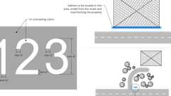Primary
Building Address
Section 503 General Building Height and Area Limitations
Diagram
UpCodes Diagram (1)
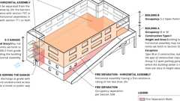
Group B or M Buildings With Group S-2 Open Parking Garage Above
503.1 General
Diagram
Unless otherwise specifically modified in Chapter 4 and this chapter, building height, number of stories and building area shall not exceed the limits specified in Sections 504 and 506 based on the type of construction as determined by Section 602 and the occupancies as determined by Section 302 except as modified hereafter. Building height, number of stories and building area provisions shall be applied independently. For the purposes of determining area limitations, height limitations and type of construction, each portion of a building separated by one or more fire walls complying with Section 706 shall be considered to be a separate building.
Exceptions:
- [HCD 1] Limited-density owner-built rural dwellings may be of any type of construction which will provide for a sound structural condition. Structural hazards which result in an unsound condition and which may constitute a substandard building are delineated by Section 17920.3 of the Health and Safety Code.
- Other than structural requirements, solar photovoltaic panels supported by a structure with no use underneath shall not constitute additional story or additional floor area and may exceed the height limit when constructed on a roof top of a building provided the following conditions are met:
  - For all occupancies, the highest point of the structure/panel shall meet the lower of the two values below:
    - 3' above the allowable building height per this code.
    - 3' above the roof of the building immediately below.
  - For installations on flat roofs in other than Group R-3 and R-4 occupancies, the highest point of the structure/panel shall meet the lower of the two values below:
    - 10' above the allowable building height per this code.
    - 10' above the roof of the building immediately below.
- Other than structural requirements, solar photovoltaic panels supported by a structure over parking stalls shall not constitute additional story or additional floor area and may exceed the height limit as specified in exception 2 (above) when the following conditions are met (see Figure 5-1):
  - The area within the perimeter of the photovoltaic array has maximum rectangular dimension of 40 feet by 150 feet.
  - The distance between solar photovoltaic array structures is a minimum of 10 feet clear.
  - The driveway aisle separating solar photovoltaic array structures has a minimum width of 25 feet clear.
  - Solar photovoltaic array structure is used only for parking purposes with no storage.
  - Completely open on all sides (other than necessary structural supports) with no interior partitions.
FIGURE 5-1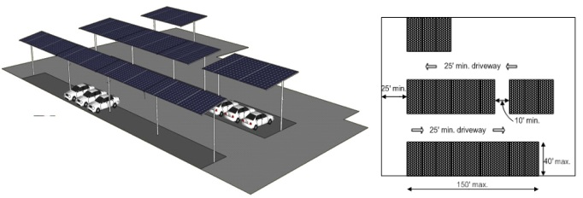
UpCodes Diagrams (4)
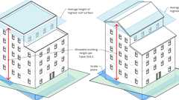
Building Height Measurements
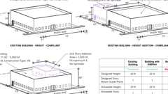
Existing Building Additions - Height
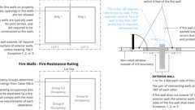
Fire Walls and Party Walls
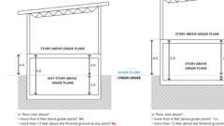
Story Above Grade Plane
503.1.1 Special Industrial Occupancies
Buildings and structures designed to house special industrial processes that require large areas and unusual building heights to accommodate craneways or special machinery and equipment, including, among others, rolling mills; structural metal fabrication shops and foundries; or the production and distribution of electric, gas or steam power, shall be exempt from the building height, number of stories and building area limitations specified in Sections 504 and 506.
503.1.2 Buildings on Same Lot
Two or more buildings on the same lot shall be regulated as separate buildings or shall be considered as portions of one building where the building height, number of stories of each building and the aggregate building area of the buildings are within the limitations specified in Sections 504 and 506. The provisions of this code applicable to the aggregate building shall be applicable to each building.
503.1.3 Type I Construction
Buildings of Type I construction permitted to be of unlimited tabular building heights and areas are not subject to the special requirements that allow unlimited area buildings in Section 507 or unlimited building height in Sections 503.1.1 and 504.3 or increased building heights and areas for other types of construction.
503.1.4 Occupiable Roofs
Diagram
A roof level or portion thereof shall not be used as an occupiable roof unless the occupancy of the roof is an occupancy that is permitted by Table 504.4 for the story immediately below the roof. The area of the occupiable roofs shall not be included in the building area as regulated by Section 506. An occupiable roof shall not be included in the building height or number of stories as regulated by Section 504, provided that the penthouses and other enclosed rooftop structures comply with Section 1511.
Exceptions:
- The occupancy located on an occupiable roof shall not be limited to the occupancies allowed on the story immediately below the roof where the building is equipped throughout with an automatic sprinkler system in accordance with Section 903.3.1.1 or 903.3.1.2 and occupant notification in accordance with Sections 907.5.2.1 and 907.5.2.3 is provided in the area of the occupiable roof. Emergency voice/alarm communication system notification per Section 907.5.2.2 shall also be provided in the area of the occupiable roof where such system is required elsewhere in the building.
- Assembly occupancies shall be permitted on roofs of open parking spaces of Type I or Type II construction, in accordance with the exception to Section 903.2.1.6.
UpCodes Diagrams (7)
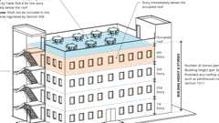Primary
Occupied Roofs
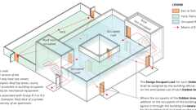
Occupant Loads: Outdoor Areas
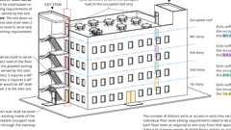
Egress From Stories or Occupied Roof
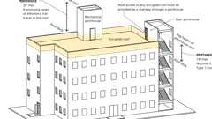
Penthouse Stair Access to Roof
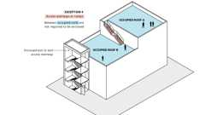
Exit Access Stair: Occupied Roofs (Ex. 9)
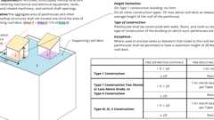
Rooftop Structures and Penthouses
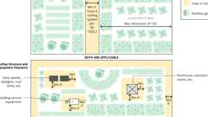
Rooftop Vegetated Areas
Building products (3)
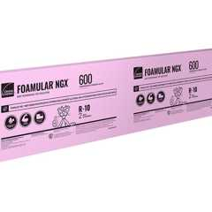
FOAMULAR® NGX® 400/600/1000
Owens Corning

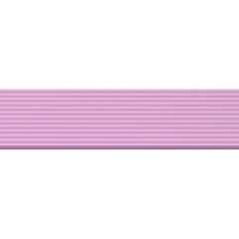
FOAMULAR® NGX® 404RB/604RB
Owens Corning

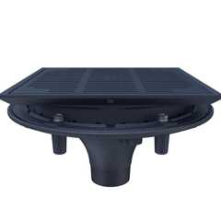
High Performance Promenade Deck Drain with Rotatable Frame and Heel-Proof Grate - Z150F
Zurn

503.1.4.1 Enclosures Over Occupiable Roof Areas
Elements or structures enclosing the occupiable roof areas shall not extend more than 48 inches (1220 mm) above the surface of the occupiable roof.
Exceptions:
- Penthouses constructed in accordance with Section 1511.2 and towers, domes, spires and cupolas constructed in accordance with Section 1511.5.
- Elements or structures enclosing the occupiable roof areas where the roof deck is located more than 75 feet (22 860 mm) above the lowest level of fire department vehicle access.
Section 504 Building Height and Number of Stories
Diagram
UpCodes Diagrams (2)
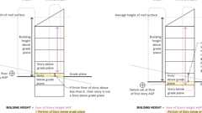
Building Height on Sloping Site
Story Above Grade Plane
504.1 General
Diagram
The height, in feet, and the number of stories of a building shall be determined based on the type of construction, occupancy classification and whether there is an automatic sprinkler system installed throughout the building.
Exception: The building height of one-story aircraft hangars, aircraft paint hangars and buildings used for the manufacturing of aircraft shall not be limited where the building is provided with an automatic sprinkler system or automatic fire-extinguishing system in accordance with Chapter 9 and is entirely surrounded by public ways or yards not less in width than one and one-half times the building height.
UpCodes Diagrams (5)
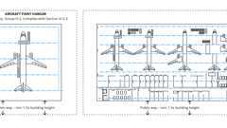Primary
Unlimited Area Aircraft Bldgs.
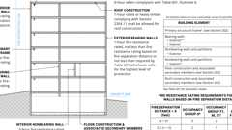
Type IIA Construction
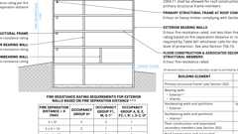
Type IIB Construction
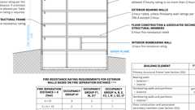
Type IIIB Const.
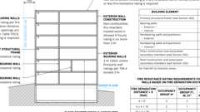
Type IIIA Construction
504.1.1 Unlimited Area Buildings
Diagram
The height of unlimited area buildings shall be designed in accordance with Section 507.
UpCodes Diagram (1)
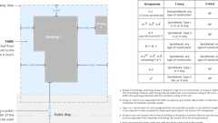
Open Spaces for Unlimited Area Bldgs.
504.1.2 Special Provisions
Diagram
The special provisions of Section 510 permit the use of special conditions that are exempt from, or modify, the specific requirements of this chapter regarding the allowable heights of buildings based on the occupancy classification and type of construction, provided the special condition complies with the provisions specified in Section 510.
UpCodes Diagrams (2)
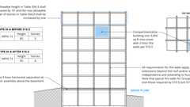
Podiums: Type IIIA Height Increase (2021)
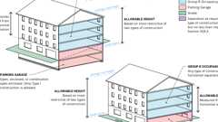
Podiums: Parking Beneath Group R
504.2 Mixed Occupancy
Diagram
In a building containing mixed occupancies in accordance with Section 508, no individual occupancy shall exceed the height and number of story limits specified in this section for the applicable occupancies.
UpCodes Diagrams (3)
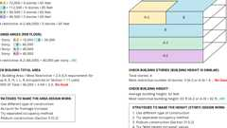
CA Nonseparated Occupancies 1
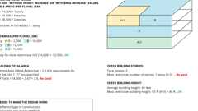
CA Nonseparated Occupancies 2
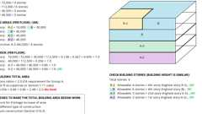
CA Separated Occupancies 1
504.3 Height in Feet
Diagram
The maximum height, in feet, of a building shall not exceed the limits specified in Table 504.3.
Exception: Towers, spires, steeples and other rooftop structures shall be constructed of materials consistent with the required type of construction of the building except where other construction is permitted by Section 1511.2.4. Such structures shall not be used for habitation or storage. The structures shall be unlimited in height where of noncombustible materials and shall not extend more than 20 feet (6096 mm) above the allowable building height where of combustible materials (see Chapter 15 for additional requirements).
TABLE 504.3—ALLOWABLE BUILDING HEIGHT IN FEET ABOVE GRADE PLANE^{a, i}
OCCUPANCY  CLASSIFICATION | TYPE OF CONSTRUCTION
OCCUPANCY  CLASSIFICATION | See Footnotes | Type I |  | Type II |  | Type III |  | Type IV |  |  |  | Type V
OCCUPANCY  CLASSIFICATION | See Footnotes | A | B | A | B | A | B | A | B | C | HT | A | B
B, F, M, S, U | NS^{b} | UL | 160 | 65 | 55 | 65 | 55 | 65 | 65 | 65 | 65 | 50 | 40
B, F, M, S, U | S | UL | 180 | 85 | 75 | 85 | 75 | 270 | 180 | 85 | 85 | 70 | 60
A, E | NS^{b} | UL | 160 | 65 | 55 | 65 | 55 | 65 | 65 | 65 | 65 | 50 | 40
A, E | S (without area increase) | UL | 180 | 85 | 75 | 85 | 75 | 270 | 180 | 85 | 85 | 70 | 60
A, E | S (with area increase) | UL | 160 | 65 | 55 | 65 | 55 | 250 | 160 | 65 | 65 | 50 | 40
H-1, H-2, H-3, H-5, L | NS^{c, d} | UL | 160 | 65 | 55 | 65 | 55 | 120 | 90 | 85 | 65 | 50 | 40
H-1, H-2, H-3, H-5, L | S (without area increase)
H-1, H-2, H-3, H-5, L | S (with area increase) | UL | 160 | 65 | 55 | 65 | 55 | 120 | 90 | 85 | 65 | 50 | 40
H-4 | NS^{c, d} | UL | 160 | 65 | 55 | 65 | 55 | 65 | 65 | 65 | 65 | 50 | 40
H-4 | S (without area increase) | UL | 180 | 85 | 75 | 85 | 75 | 140 | 100 | 85 | 85 | 70 | 60
H-4 | S (with area increase) | UL | 160 | 65 | 55 | 65 | 55 | 120 | 160 | 65 | 65 | 50 | 40
I-3 | NS^{d, e} | UL | 160 | NP | NP | NP | NP | NP | NP | NP | NP | NP | NP
I-3 | S (without area increase) | UL | 180 | NP | NP | NP | NP | NP | NP | NP | NP | NP | NP
I-3 | S (with area increase) | UL | 160 | NP | NP | NP | NP | NP | NP | NP | NP | NP | NP
I-2 | NS^{d, e, f} | UL | 160 | 65 | 55 | 65 | NP | NP | NP | NP | 65 | 50 | NP
I-2 | S (without area increase) | UL | 180 | 85 | 55 | 65 | NP | NP | NP | NP | 65 | 50 | NP
I-2 | S (with area increase) | UL | 160 | 65 | 55 | 65 | NP | NP | NP | NP | 65 | 50 | NP
I-4 | NS^{d, g} | UL | 160 | 65 | 55 | 65 | 55 | 65 | 65 | 65 | 65 | 50 | 40
I-4 | S (without area increase) | UL | 180 | 85 | 75 | 85 | 75 | 180 | 120 | 85 | 85 | 70 | 60
I-4 | S (with area increase) | UL | 160 | 65 | 55 | 65 | 55 | 160 | 100 | 65 | 65 | 50 | 50
R-1^{h} | NS^{d} | UL | 160 | 65 | 55 | 65 | 55 | 65 | 65 | 65 | 65 | 50 | 40
R-1^{h} | S13D | 60 | 60 | 60 | 60 | 60 | 60 | 60 | 60 | 60 | 60 | 50 | 40
R-1^{h} | S13R | 60 | 60 | 60 | 60 | 60 | 60 | 60 | 60 | 60 | 60 | 60 | 60
R-1^{h} | S (without area increase) | UL | 180 | 85 | 75 | 85 | 75 | 270 | 180 | 85 | 85 | 70 | 60
R-1^{h} | S (with area increase) | UL | 160 | 65 | 55 | 65 | 55 | 250 | 160 | 65 | 65 | 50 | 40
R-2^{h} | NS^{d} | UL | 160 | 65 | 55 | 65 | 55 | 65 | 65 | 65 | 65 | 50 | 40
R-2^{h} | S13R | 60 | 60 | 60 | 55 | 60 | 55 | 60 | 60 | 60 | 60 | 50 | 40
R-2^{h} | S (without area increase) | UL | 180 | 85 | 75 | 85 | 75 | 270 | 180 | 85 | 85 | 70 | 60
R-2^{h} | S (with area increase) | UL | 160 | 65 | 55 | 65 | 55 | 250 | 160 | 65 | 65 | 60 ^{j} | 40
R-2.1^{h} | NS^{d} | UL | 160 | 65 | 55 | 65 | 55 | 65 | NP | NP | NP | 50 | 40
R-2.1^{h} | S13D | 60 | 60 | 60 | 55 | 60 | 55 | 60 | NP | NP | NP | 50 | 40
R-2.1^{h} | S13R | 60 | 60 | 60 | 55 | 60 | 55 | 60 | NP | NP | NP | 50 | 40
R-2.1^{h} | S | UL | 160 | 65 | 55 | 65 | 55 | 270 | NP | NP | NP | 50 | 40
R-2.2^{h} | NS^{d} | NP | NP | NP | NP | NP | NP | NP | NP | NP | NP | NP | NP
R-2.2^{h} | S (without area increase) | UL | 180 | 85 | NP | 85 | NP | 270 | 180 | 85 | 85 | 70 | NP
R-2.2^{h} | S (with area increase) | UL | 160 | 65 | NP | 65 | NP | 250 | 160 | 65 | 65 | 60 ^{i} | NP
R-3, R-3.1^{h} | NS^{d} | UL | 160 | 65 | 55 | 65 | 55 | 65 | 65 | 65 | 65 | 50 | 40
R-3, R-3.1^{h} | S13D | 60 | 60 | 60 | 60 | 60 | 60 | 60 | 60 | 60 | 60 | 50 | 40
R-3, R-3.1^{h} | S13R | 60 | 60 | 60 | 55 | 60 | 55 | 60 | 60 | 60 | 60 | 60 | 60
R-3, R-3.1^{h} | S | UL | 160 | 65 | 55 | 65 | 55 | 270 | 180 | 85 | 65 | 70 | 60
R-4^{h} | NS^{d} | UL | 160 | 65 | 55 | 65 | 55 | 65 | 65 | 65 | 65 | 50 | 40
R-4^{h} | S13D | 60 | 60 | 60 | 55 | 60 | 55 | 60 | 60 | 60 | 60 | 50 | 40
R-4^{h} | S13R | 60 | 60 | 60 | 55 | 60 | 55 | 60 | 60 | 60 | 60 | 50 | 40
R-4^{h} | S | UL | 160 | 65 | 55 | 65 | 55 | 270 | 180 | 85 | 65 | 50 | 40
For SI: 1 foot = 304.8 mm.
UL = Unlimited; NS = Buildings not equipped throughout with an automatic sprinkler system; S = Buildings equipped throughout with an automatic sprinkler system installed in accordance with Section 903.3.1.1; S13R = Buildings equipped throughout with an automatic sprinkler system installed in accordance with Section 903.3.1.2; S13D = Buildings equipped throughout with an automatic sprinkler system installed in accordance with Section 903.3.1.3.
- See Chapters 4 and 5 for specific exceptions to the allowable height in this chapter.
- See Section 903.2 for the minimum thresholds for protection by an automatic sprinkler system for specific occupancies.
- New Group H and all Group L occupancies are required to be protected by an automatic sprinkler system in accordance with Section 903.2.5.
- The NS value is only for use in evaluation of existing building height in accordance with the California Existing Building Code.
- New Group I-3 occupancies are required to be protected by an automatic sprinkler system in accordance with Section 903.2.6.
- New and existing Group I-2 occupancies are required to be protected by an automatic sprinkler system in accordance with Section 903.2.6 and with Section 1103.5 of the California Fire Code.
- For new Group I-4 occupancies, see Exceptions 2 and 3 of Section 903.2.6.
- New Group R occupancies are required to be protected by an automatic sprinkler system in accordance with Section 903.2.8.
- In other than Group A, E, H, I, L and R occupancies, high-rise buildings, and other applications listed in Section 1.11 regulated by the Office of the State Fire Marshal, the S increases for height and stories in Tables 504.3 and 504.4 are permitted in addition to the S area increase in accordance with Table 506.2.
- For Group R-2 buildings of Type VA construction equipped throughout with an approved automatic sprinkler system in accordance with Section 903.3.1.1, S area increase is permitted in addition to the height and story increase provided the height shall not exceed 60 feet and 4 stories.
UpCodes Diagrams (4)
Primary
Building Height on Sloping Site
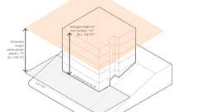Primary
Allowable Height Above Grade Plane
Primary
Building Height Measurements
Story Above Grade Plane
504.4 Number of Stories
Diagram
The maximum number of stories above grade plane of a building shall not exceed the limits specified in Table 504.4.
TABLE 504.4—ALLOWABLE NUMBER OF STORIES ABOVE GRADE PLANE^{a, b, n}
OCCUPANCY  CLASSIFICATION | TYPE OF CONSTRUCTION
OCCUPANCY  CLASSIFICATION | See Footnotes | Type I |  | Type II |  | Type III |  | Type IV |  |  |  | Type V
OCCUPANCY  CLASSIFICATION | See Footnotes | A | B | A | B | A | B | A | B | C | HT | A | B
A-1 | NS | UL | 5 | 3 | 2 | 3 | 2 | 3 | 3 | 3 | 3 | 2 | 1
A-1 | S (without area increase) | UL | 6 | 4 | 3 | 4 | 3 | 9 | 6 | 4 | 4 | 3 | 2
A-1 | S (with area increase) | UL | 5 | 3 | 2 | 3 | 2 | 8 | 5 | 3 | 3 | 2 | 1
A-2 | NS | UL | 11 | 3 | 2 | 3 | 2 | 3 | 3 | 3 | 3 | 2 | 1
A-2 | S (without area increase) | UL | 12 | 4 | 3 | 4 | 3 | 18 | 12 | 6 | 4 | 3 | 2
A-2 | S (with area increase) | UL | 11 | 3 | 2 | 3 | 2 | 17 | 11 | 5 | 3 | 2 | 1
A-3 | NS | UL | 11 | 3 | 2 | 3 | 2 | 3 | 3 | 3 | 3 | 2 | 1
A-3 | S (without area increase) | UL | 12 | 4 | 3 | 4 | 3 | 18 | 12 | 6 | 4 | 3 | 2
A-3 | S (with area increase) | UL | 11 | 3 | 2 | 3 | 2 | 17 | 11 | 5 | 3 | 2 | 1
A-4 | NS | UL | 11 | 3 | 2 | 3 | 2 | 3 | 3 | 3 | 3 | 2 | 1
A-4 | S (without area increase) | UL | 12 | 4 | 3 | 4 | 3 | 18 | 12 | 6 | 4 | 3 | 2
A-4 | S (with area increase) | UL | 11 | 3 | 2 | 3 | 2 | 17 | 11 | 5 | 3 | 2 | 1
A-5 | NS | UL | UL | UL | UL | UL | UL | 1 | 1 | 1 | UL | UL | UL
A-5 | S | UL | UL | UL | UL | UL | UL | UL | UL | UL | UL | UL | UL
B | NS | UL | 11 | 5 | 3 | 5 | 3 | 5 | 5 | 5 | 5 | 3 | 2
B | S | UL | 12 | 6 | 4 | 6 | 4 | 18 | 12 | 9 | 6 | 4 | 3
E | NS | UL | 5 | 3 | 2 | 3 | 2 | 3 | 3 | 3 | 3 | 1 | 1
E | S (without area increase) | UL | 6 | 4 | 3 | 4 | 3 | 9 | 6 | 4 | 4 | 2 | 2
E | S (with area increase) | UL | 5 | 3 | 2 | 3 | 2 | 8 | 7 | 3 | 3 | 1 | 1
F-1 | NS | UL | 11 | 4 | 2 | 3 | 2 | 3 | 3 | 3 | 4 | 2 | 1
F-1 | S | UL | 12 | 5 | 3 | 4 | 3 | 10 | 7 | 5 | 5 | 3 | 2
F-2 | NS | UL | 11 | 5 | 3 | 4 | 3 | 5 | 5 | 5 | 5 | 3 | 2
F-2 | S | UL | 12 | 6 | 4 | 5 | 4 | 12 | 8 | 6 | 6 | 4 | 3
H-1 | NS^{c, d} | 1 | 1 | 1 | 1 | 1 | 1 | NP | NP | NP | 1 | 1 | NP
H-1 | S |  |  |  |  |  |  | 1 | 1 | 1 | 1 | 1 | NP
H-2 | NS^{c, d} | 20 | 3 | 2 | 1 | 2 | 1 | 1 | 1 | 1 | 2 | 1 | 1
H-2 | S |  |  |  |  |  |  | 2 | 2 | 2 | 2 | 1 | 1
H-3 | NS^{c, d} | 20 | 6 | 4 | 2 | 4 | 2 | 3 | 3 | 3 | 4 | 2 | 1
H-3 | S |  |  |  |  |  |  | 4 | 4 | 4 | 4 | 2 | 1
H-4 | NS^{c, d} | UL | 7 | 5 | 3 | 5 | 3 | 5 | 5 | 5 | 5 | 3 | 2
H-4 | S (without area increase) | UL | 8 | 6 | 4 | 6 | 4 | 8 | 7 | 6 | 6 | 4 | 3
H-4 | S (with area increase) | 20 | 7 | 5 | 3 | 5 | 3 | 7 | 6 | 5 | 5 | 3 | 2
H-5 | NS^{c, d} | 4 | 4 | 3 | 3 | 3 | 3 | 2 | 2 | 2 | 3 | 3 | 2
H-5 | S |  |  |  |  |  |  | 3 | 3 | 3 | 3 | 3 | 2
I-2^{i,j} | NS ^{d, f} | UL | 4 | 2 | 1 | 1 | NP | NP | NP | NP | 1 | 1 | NP
I-2^{i,j} | S (without area increase) | UL | 5 | 3 | 1 | 1 | NP | NP | NP | NP | 1 | 1 | NP
I-2^{i,j} | S (with area increase) | UL | 4 | 2 | 1 | 1 | NP | NP | NP | NP | 1 | 1 | NP
I-3 | NS ^{d, e} | NP | NP | NP | NP | NP | NP | NP | NP | NP | NP | NP | NP
I-3 | S (without area increase) | UL | 5 | NP | NP | NP | NP | NP | NP | NP | NP | NP | NP
I-3 | S (with area increase) | UL | 2 | NP | NP | NP | NP | NP | NP | NP | NP | NP | NP
I-4^{p} | NS ^{d, g} | UL | 5 | 3 | 2 | 3 | 2 | 3 | 3 | 3 | 3 | 1 | 1
I-4^{p} | S (without area increase) | UL | 6 | 4 | 3 | 4 | 3 | 9 | 6 | 4 | 4 | 2 | 2
I-4^{p} | S (with area increase) | UL | 5 | 3 | 2 | 3 | 2 | 8 | 5 | 3 | 3 | 1 | 1
L | NS | NP | NP | NP | NP | NP | NP | NP | NP | NP | NP | NP | NP
L | S | 20 | 6 | 5 | 3 | 5 | 3 | 8 | 6 | 5 | 5 | 3 | 2
M | NS | UL | 11 | 4 | 2 | 4 | 2 | 4 | 4 | 4 | 4 | 3 | 1
M | S | UL | 12 | 5 | 3 | 5 | 3 | 12 | 8 | 6 | 5 | 4 | 2
R-1^{h} | NS^{d} | UL | 11 | 4 | 4 | 4 | 4 | 4 | 4 | 4 | 4 | 3 | 2
R-1^{h} | S13R | 4 | 4 |  |  |  |  |  |  |  |  | 4 | 3
R-1^{h} | S (without area increase) | UL | 12 | 5 | 5 | 5 | 5 | 18 | 12 | 8 | 5 | 4 | 3
R-1^{h} | S (with area increase) | UL | 11 | 4 | 4 | 4 | 4 | 17 | 11 | 7 | 4 | 3 | 2
R-2^{h} | NS^{d} | UL | 11 | 4 | 4 | 4 | 4 | 4 | 4 | 4 | 4 | 3 | 2
R-2^{h} | S13R | 4 | 4 | 4 |  |  |  |  |  |  |  | 3 | 2
R-2^{h} | S (without area increase) | UL | 12 | 5 | 5 | 5 | 5 | 18 | 12 | 8 | 5 | 4 | 3
R-2^{h} | S (with area increase) | UL | 11 | 4 | 4 | 4 | 4 | 17 | 11 | 7 | 4 | 4º | 2
R-2.1^{h} | NS^{d} | UL | 6^{l} | 3^{k} | NP | 3^{k} | NP | 4 | NP | NP | NP | 3^{k} | NP
R-2.1^{h} | S13R | UL | 4^{l} | 3^{k} | NP | 3^{k} | NP | 4 | NP | NP | NP | 3^{k} | NP
R-2.1^{h} | S | UL | 6^{l} | 3^{k} | NP | 3^{k} | NP | 10 | NP | NP | NP | 3^{k} | NP
R-2.2^{h} | NS^{d} | NP | NP | NP | NP | NP | NP | NP | NP | NP | NP | NP | NP
R-2.2^{h} | S (without area increase) | UL | 12 | 5 | NP | 5 | NP | 18 | 12 | 8 | 5 | 4 | NP
R-2.2^{h} | S (with area increase) | UL | 11 | 4 | NP | 4 | NP | 17 | 11 | 7 | 4 | 4º | NP
R-3, R-3.1^{h} | NS^{d} | UL | 11 | 4 | 4 | 4 | 4 | 4 | 4 | 4 | 4 | 3 | 3
R-3, R-3.1^{h} | S13D | 4 | 4 |  |  |  |  |  |  |  |  | 3 | 3
R-3, R-3.1^{h} | S13R | 4 | 4 |  |  |  |  |  |  |  |  | 4 | 4
R-3, R-3.1^{h} | S | UL | 12 | 5 | 5 | 5 | 5 | 18 | 12 | 5 | 5 | 4 | 4
R-4^{h} | NS^{d} | UL | 11^{l} | 4^{k} | 4^{m} | 4^{k} | 4^{m} | 4^{m} | 4^{m} | 4^{m} | 4^{m} | 3^{k} | 2^{m}
R-4^{h} | S13D | 4 | 4^{l} |  |  |  |  |  |  |  |  | 3^{k} | 2^{m}
R-4^{h} | S13R | 4 | 4^{l} |  |  |  |  |  |  |  |  | 4 | 3
R-4^{h} | S | UL | 11^{l} | 5 | 5 | 5 | 5 | 11^{l} | 5 | 5 | 5 | 4 | 3
S-1 | NS | UL | 11 | 4 | 2 | 3 | 2 | 4 | 4 | 4 | 4 | 3 | 1
S-1 | S | UL | 12 | 5 | 4 | 4 | 4 | 10 | 7 | 5 | 5 | 4 | 2
S-2^{i} | NS | UL | 11 | 5 | 3 | 4 | 3 | 4 | 4 | 4 | 5 | 4 | 2
S-2^{i} | S | UL | 12 | 6 | 4 | 5 | 4 | 12 | 8 | 5 | 6 | 5 | 3
U | NS | UL | 5 | 4 | 2 | 3 | 2 | 4 | 4 | 4 | 4 | 2 | 1
U | S | UL | 6 | 5 | 3 | 4 | 3 | 9 | 6 | 5 | 5 | 3 | 2
UL = Unlimited; NP = Not Permitted; NS = Buildings not equipped throughout with an automatic sprinkler system; S = Buildings equipped throughout with an automatic sprinkler system installed in accordance with Section 903.3.1.1; S13R = Buildings equipped throughout with an automatic sprinkler system installed in accordance with Section 903.3.1.2; S13D = Buildings equipped throughout with an automatic sprinkler system installed in accordance with Section 903.3.1.3.
- See Chapters 4 and 5 for specific exceptions to the allowable height in this chapter.
- See Section 903.2 for the minimum thresholds for protection by an automatic sprinkler system for specific occupancies.
- New Group H occupancies are required to be protected by an automatic sprinkler system in accordance with Section 903.2.5.
- The NS value is only for use in evaluation of existing building height in accordance with the California Existing Building Code.
- New Group I-3 occupancies are required to be protected by an automatic sprinkler system in accordance with Section 903.2.6.
- New and existing Group I-2 occupancies are required to be protected by an automatic sprinkler system in accordance with Section 903.2.6 and Section 1103.5 of the California Fire Code
- For new Group I-4 occupancies, see Exceptions 2 and 3 of Section 903.2.6.
- New Group R occupancies are required to be protected by an automatic sprinkler system in accordance with Section 903.2.8.
- See Sections 407.1.1 and 408.1.2 for specific exceptions to construction type, allowable building areas and allowable heights.
- Restraint shall not be permitted in any building except in Group I-3 occupancies constructed for such use (see Section 408.1.2).
- Nonambulatory persons shall be limited to the first 2 stories.
- Nonambulatory persons shall be limited to the first 5 stories.
- Nonambulatory elderly clients are not permitted in buildings of these types of construction. See Sections 435.3.3 and 435.3.4.
- In other than Group A, E, H, I, L and R occupancies, high-rise buildings, and other applications listed in Section 1.11 regulated by the Office of the State Fire Marshal, the S increases for height and stories in Tables 504.3 and 504.4 are permitted in addition to the S area increase in accordance with Table 506.2.
- For Group R-2 buildings of Type VA construction equipped throughout with an approved automatic sprinkler system in accordance with Section 903.3.1.1, S area increase is permitted in addition to the height and story increase provided the height shall not exceed 60 feet and 4 stories.
- See Section 436.1 for additional regulations for child-care centers and adult day care.
UpCodes Diagrams (2)
Podiums: Type IIIA Height Increase (2021)
Story Above Grade Plane
Section 505 Mezzanines and Equipment Platforms
Diagram
UpCodes Diagrams (6)
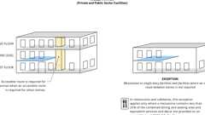Primary
Routes: Mezzanines
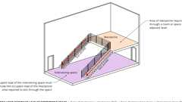
Cumulative Occ. Loads: Mezzanines
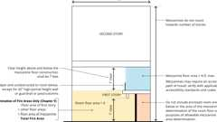
Mezzanines
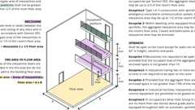
Mezzanine Area Example - Pt. 1
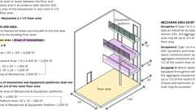
Mezzanine Area Example - Pt. 2
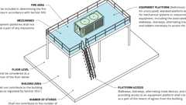
Equipment Platforms
505.1 General
Mezzanines shall comply with Section 505.2. Equipment platforms shall comply with Section 505.3.
505.2 Mezzanines
Diagram
A mezzanine or mezzanines in compliance with Section 505.2 shall be considered a portion of the story below. Such mezzanines shall not contribute to either the building area or number of stories as regulated by Section 503.1. The area of the mezzanine shall be included in determining the fire area. The clear height above and below the mezzanine floor construction shall be not less than 7 feet (2134 mm).
UpCodes Diagrams (4)
Primary
Mezzanine Area Example - Pt. 2
Primary
Mezzanine Area Example - Pt. 1
Primary
Mezzanines
Cumulative Occ. Loads: Mezzanines
505.2.1 Area Limitation
The aggregate area of a mezzanine or mezzanines within a room shall be not greater than one-third of the floor area of that room or space in which they are located. The enclosed portion of a room shall not be included in a determination of the floor area of the room in which the mezzanine is located. In determining the allowable mezzanine area, the area of the mezzanine shall not be included in the floor area of the room.
Exceptions:
- The aggregate area of mezzanines in buildings and structures of Type I or II construction for special industrial occupancies in accordance with Section 503.1.1 shall be not greater than two-thirds of the floor area of the room.
- The aggregate area of mezzanines in buildings and structures of Type I or II construction shall be not greater than one-half of the floor area of the room in buildings and structures equipped throughout with an approved automatic sprinkler system in accordance with Section 903.3.1.1 and an approved emergency voice/alarm communication system in accordance with Section 907.5.2.2.
- The aggregate area of a mezzanine within a dwelling unit that is located in a building equipped throughout with an approved automatic sprinkler system in accordance with Section 903.3.1.1 or 903.3.1.2 shall not be greater than one-half of the floor area of the room, provided that:
  - Except for enclosed closets and bathrooms, the mezzanine shall be open to the room in which such mezzanine is located;
  - The opening to the room shall be unobstructed except for walls not more than 42 inches (1067 mm) in height, columns and posts; and
  - Exceptions to Section 505.2.3 shall not be permitted.
505.2.1.1 Aggregate Area of Mezzanines and Equipment Platforms
Where a room contains both a mezzanine and an equipment platform, the aggregate area of the two raised floor levels shall be not greater than two-thirds of the floor area of that room or space in which they are located. The area of the mezzanine shall not exceed the area determined in accordance with Section 505.2.1.
505.2.2 Means of Egress
Diagram
The means of egress for mezzanines shall comply with the applicable provisions of Chapter 10.
UpCodes Diagram (1)
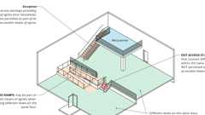
Exit Access Stairs: Accessible Means of Egress
505.2.3 Openness
Diagram
A mezzanine shall be open and unobstructed to the room in which such mezzanine is located except for walls not more than 42 inches (1067 mm) in height, columns and posts.
Exceptions:
- Mezzanines or portions thereof are not required to be open to the room in which the mezzanines are located, provided that the occupant load of the aggregate area of the enclosed space is not greater than 10.
- A mezzanine having two or more exits or access to exits is not required to be open to the room in which the mezzanine is located.
- Mezzanines or portions thereof are not required to be open to the room in which the mezzanines are located, provided that the aggregate floor area of the enclosed space is not greater than 10 percent of the mezzanine area.
- In industrial facilities, mezzanines used for control equipment are permitted to be glazed on all sides.
- In occupancies other than Groups H and I, which are no more than two stories above grade plane and equipped throughout with an automatic sprinkler system in accordance with Section 903.3.1.1, a mezzanine having two or more exits or access to exits shall not be required to be open to the room in which the mezzanine is located.
UpCodes Diagram (1)
Mezzanine Area Example - Pt. 1
505.3 Equipment Platforms
Diagram
Equipment platforms in buildings shall not be considered as a portion of the floor below. Such equipment platforms shall not contribute to either the building area or the number of stories as regulated by Section 503.1. The area of the equipment platform shall not be included in determining the fire area in accordance with Section 903. Equipment platforms shall not be a part of any mezzanine and such platforms and the walkways, stairways, alternating tread devices and ladders providing access to an equipment platform shall not serve as a part of the means of egress from the building.
UpCodes Diagrams (3)
Primary
Equipment Platforms
Mezzanine Area Example - Pt. 1
Mezzanine Area Example - Pt. 2
Building products (19)
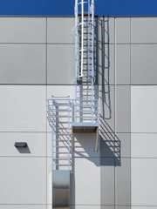
Heavy Duty Tubular Rail Fixed Access Ladder - 501 Access Ladder
O'Keeffe's

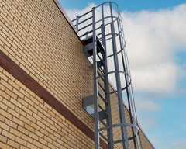
High Parapet Access with Platform and Return - 533 Cage Ladder
O'Keeffe's

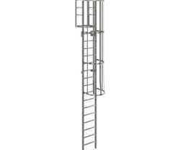
Low Parapet Access with Platform and No Return - 533A Cage Ladder
O'Keeffe's

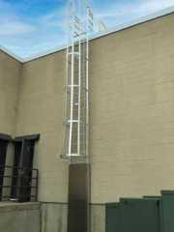
Low Parapet Access with Roofover Rail Extensions - 532 Cage Ladder
O'Keeffe's

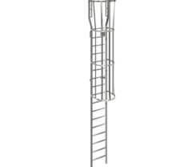
Low Parapet with Walk Through Rail Extension - 534 Cage Ladder
O'Keeffe's

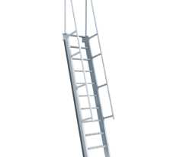
Ship Ladder (60 degrees) - 520A Ship Ladder
O'Keeffe's

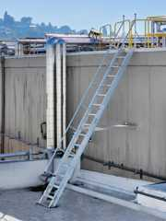
Ship Ladder (75 degrees) - 520 Ship Ladder
O'Keeffe's

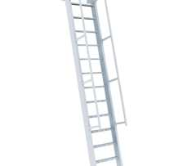
Ship Ladder with Access to Roof Hatch (60 degrees) - 523A Ship Ladder
O'Keeffe's

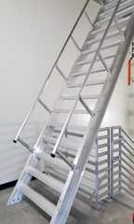
Ship Ladder with Access to Roof Hatch (75 degrees) - 523 Ship Ladder
O'Keeffe's

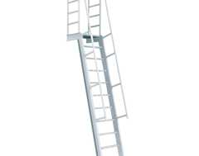
Ship Ladder with Platform (60 degrees) - 521A Ship Ladder
O'Keeffe's

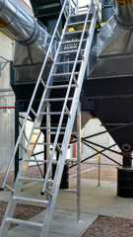
Ship Ladder with Platform (75 degrees) - 521 Ship Ladder
O'Keeffe's

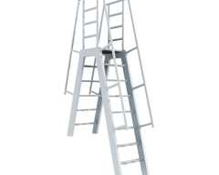
Ship Ladder with Platform and Return (60 degrees) - 522A Ship Ladder
O'Keeffe's

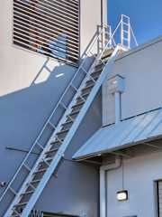
Ship Ladder with Platform and Return (75 degrees) - 522 Ship Ladder
O'Keeffe's

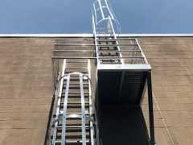
Standard Cage Ladder - 531 Cage Ladder
O'Keeffe's

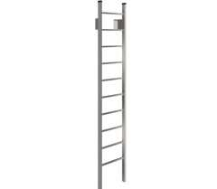
Standard Duty Channel Rail Fixed Access Ladder - 500 Access Ladder
O'Keeffe's

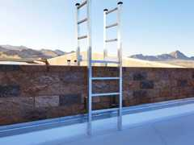
Tubular Rail High Parapet Access Ladder with Platform and Return - 503 Access Ladder
O'Keeffe's

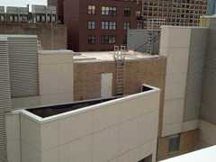
Tubular Rail Low Parapet Access Ladder with Platform Only - 503A Access Ladder
O'Keeffe's

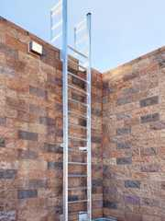
Tubular Rail Low Parapet Access Ladder with Roofover Rail Extensions - 502 Access Ladder
O'Keeffe's

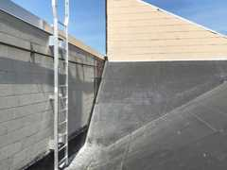
Tubular Rail Low Parapet Access Ladder with Walk Through Rail Extensions - 504 Access Ladder
O'Keeffe's

505.3.1 Area Limitation
The aggregate area of all equipment platforms within a room shall be not greater than two-thirds of the area of the room in which they are located. Where an equipment platform is located in the same room as a mezzanine, the area of the mezzanine shall be determined by Section 505.2.1 and the combined aggregate area of the equipment platforms and mezzanines shall be not greater than two-thirds of the room in which they are located. The area of the mezzanine shall not exceed the area determined in accordance with Section 505.2.1.
505.3.2 Automatic Sprinkler System
Diagram
Where located in a building that is required to be protected by an automatic sprinkler system, equipment platforms shall be fully protected by sprinklers above and below the platform, where required by the standards referenced in Section 903.3.
UpCodes Diagram (1)
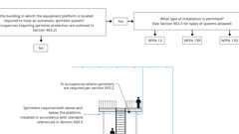
Sprinklers: Equipment Platforms
505.3.3 Guards
Diagram
Equipment platforms shall have guards where required by Section 1015.2.
UpCodes Diagrams (2)
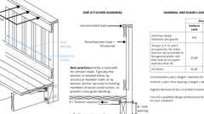
Guards: Connection Requirements
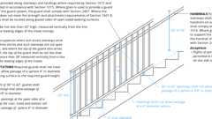
Guards: Stairs (Non-Res)
Section 506 Building Area
Diagram
UpCodes Diagrams (2)
Occupied Roofs
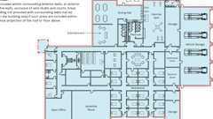
Building Area (Definition)
506.1 General
Diagram
The floor area of a building shall be determined based on the type of construction, occupancy classification, whether there is an automatic sprinkler system installed throughout the building and the amount of building frontage on public way or open space.
UpCodes Diagrams (4)
Type IIA Construction
Type IIB Construction
Type IIIB Const.
Type IIIA Construction
506.1.1 Unlimited Area Buildings
Unlimited area buildings shall be designed in accordance with Section 507.
506.1.2 Special Provisions
The special provisions of Section 510 permit the use of special conditions that are exempt from, or modify, the specific requirements of this chapter regarding the allowable areas of buildings based on the occupancy classification and type of construction, provided the special condition complies with the provisions specified in Section 510.
506.1.3 Basements
Basements need not be included in the total allowable floor area of a building provided the total area of such basements does not exceed the area permitted for a one-story above grade plane building.
506.2 Allowable Area Determination
Diagram
The allowable area of a building shall be determined in accordance with the applicable provisions of Sections 506.2.1, 506.2.2 and 506.3.
TABLE 506.2—ALLOWABLE AREA FACTOR (A_{t} = NS, S1, S13R, S13D or SM, as applicable) IN SQUARE FEET^{a, b, j}
OCCUPANCY  CLASSIFICATION | SEE FOOTNOTES | TYPE OF CONSTRUCTION
OCCUPANCY  CLASSIFICATION | SEE FOOTNOTES | Type I |  | Type II |  | Type III |  | Type IV |  |  |  | Type V
OCCUPANCY  CLASSIFICATION | SEE FOOTNOTES | A | B | A | B | A | B | A | B | C | HT | A | B
A-1 | NS | UL | UL | 15,500 | 8,500 | 14,000 | 8,500 | 45,000 | 30,000 | 18,750 | 15,000 | 11,500 | 5,500
A-1 | S1 | UL | UL | 62,000 | 34,000 | 56,000 | 34,000 | 180,000 | 120,000 | 75,000 | 60,000 | 46,000 | 22,000
A-1 | SM (without height increase) | UL | UL | 46,500 | 25,500 | 42,000 | 25,500 | 135,000 | 90,000 | 56,250 | 45,000 | 34,500 | 16,500
A-1 | SM (with height increase) | UL | UL | 15,500 | 8,500 | 14,000 | 8,500 | 45,000 | 30,000 | 18,750 | 15,000 | 11,500 | 5,500
A-2 | NS | UL | UL | 15,500 | 9,500 | 14,000 | 9,500 | 45,000 | 30,000 | 18,750 | 15,000 | 11,500 | 6,000
A-2 | S1 | UL | UL | 62,000 | 38,000 | 56,000 | 38,000 | 180,000 | 120,000 | 75,000 | 60,000 | 46,000 | 24,000
A-2 | SM (without height increase) | UL | UL | 46,500 | 28,500 | 42,000 | 28,500 | 135,000 | 90,000 | 56,250 | 45,000 | 34,500 | 18,000
A-2 | SM (with height increase) | UL | UL | 15,500 | 9,500 | 14,000 | 9,500 | 45,000 | 30,000 | 18,750 | 15,000 | 11,500 | 6,000
A-3 | NS | UL | UL | 15,500 | 9,500 | 14,000 | 9,500 | 45,000 | 30,000 | 18,750 | 15,000 | 11,500 | 6,000
A-3 | S1 | UL | UL | 62,000 | 38,000 | 56,000 | 38,000 | 180,000 | 120,000 | 75,000 | 60,000 | 46,000 | 24,000
A-3 | SM (without height increase) | UL | UL | 46,500 | 28,500 | 42,000 | 28,500 | 135,000 | 90,000 | 56,250 | 45,000 | 34,500 | 18,000
A-3 | SM (with height increase) | UL | UL | 15,500 | 9,500 | 14,000 | 9,500 | 45,000 | 30,000 | 18,750 | 15,000 | 11,500 | 6,000
A-4 | NS | UL | UL | 15,500 | 9,500 | 14,000 | 9,500 | 45,000 | 30,000 | 18,750 | 15,000 | 11,500 | 6,000
A-4 | S1 | UL | UL | 62,000 | 38,000 | 56,000 | 38,000 | 180,000 | 120,000 | 75,000 | 60,000 | 46,000 | 24,000
A-4 | SM (without height increase) | UL | UL | 46,500 | 28,500 | 42,000 | 28,500 | 135,000 | 90,000 | 56,250 | 45,000 | 34,500 | 18,000
A-4 | SM (with height increase) | UL | UL | 15,500 | 9,500 | 14,000 | 9,500 | 45,000 | 30,000 | 18,750 | 15,000 | 11,500 | 6,000
A-5 | NS | UL | UL | UL | UL | UL | UL | UL | UL | UL | UL | UL | UL
A-5 | S1
A-5 | SM
B | NS | UL | UL | 37,500 | 23,000 | 28,500 | 19,000 | 108,000 | 72,000 | 45,000 | 36,000 | 18,000 | 9,000
B | S1 | UL | UL | 150,000 | 92,000 | 114,000 | 76,000 | 432,000 | 288,000 | 180,000 | 144,000 | 72,000 | 36,000
B | SM | UL | UL | 112,500 | 69,000 | 85,500 | 57,000 | 324,000 | 216,000 | 135,000 | 108,000 | 54,000 | 27,000
E | NS | UL | UL | 26,500 | 14,500 | 23,500 | 14,500 | 76,500 | 51,000 | 31,875 | 25,500 | 18,500 | 9,500
E | S1 | UL | UL | 106,000 | 58,000 | 94,000 | 58,000 | 306,000 | 204,000 | 127,500 | 102,000 | 74,000 | 38,000
E | SM (without height increase) | UL | UL | 79,500 | 43,500 | 70,500 | 43,500 | 229,500 | 153,000 | 95,625 | 76,500 | 55,500 | 28,500
E | SM (with height increase) | UL | UL | 26,500 | 14,500 | 23,500 | 14,500 | 76,500 | 51,000 | 31,875 | 25,500 | 18,500 | 9.500
F-1 | NS | UL | UL | 25,000 | 15,500 | 19,000 | 12,000 | 100,500 | 67,000 | 41,875 | 33,500 | 14,000 | 8,500
F-1 | S1 | UL | UL | 100,000 | 62,000 | 76,000 | 48,000 | 402,000 | 268,000 | 167,500 | 134,000 | 56,000 | 34,000
F-1 | SM | UL | UL | 75,000 | 46,500 | 57,000 | 36,000 | 301,500 | 201,000 | 125,625 | 100,500 | 42,000 | 25,500
F-2 | NS | UL | UL | 37,500 | 23,000 | 28,500 | 18,000 | 151,500 | 101,000 | 63,125 | 50,500 | 21,000 | 13,000
F-2 | S1 | UL | UL | 150,000 | 92,000 | 114,000 | 72,000 | 606,000 | 404,000 | 252,500 | 202,000 | 84,000 | 52,000
F-2 | SM | UL | UL | 112,500 | 69,000 | 85,500 | 54,000 | 454,500 | 303,000 | 189,375 | 151,500 | 63,000 | 39,000
H-1 | NS^{c} | 21,000 | 16,500 | 11,000 | 7,000 | 9,500 | 7,000 | 10,500 | 10,500 | 10,500 | 10,500 | 7,500 | NP
H-1 | S1
H-2 | NS^{c} | 21,000 | 16,500 | 11,000 | 7,000 | 9,500 | 7,000 | 10,500 | 10,500 | 10,500 | 10,500 | 7,500 | 3,000
H-2 | S1
H-2 | SM
H-3 | NS^{c} | UL | 60,000 | 26,500 | 14,000 | 17,500 | 13,000 | 25,500 | 25,500 | 25,500 | 25,500 | 10,000 | 5,000
H-3 | S1
H-3 | SM
H-4 | NS^{c, d} | UL | UL | 37,500 | 17,500 | 28,500 | 17,500 | 72,000 | 54,000 | 40,500 | 36,000 | 18,000 | 6,500
H-4 | S1 | UL | UL | 150,000 | 70,000 | 114,000 | 70,000 | 288,000 | 216,000 | 162,000 | 144,000 | 72,000 | 26,000
H-4 | SM (without height increase) | UL | UL | 112,500 | 52,500 | 85,500 | 52,500 | 216,000 | 162,000 | 121,500 | 108,000 | 54,000 | 19,500
H-4 | SM (with height increase) | UL | UL | 37,500 | 17,500 | 28,500 | 17,500 | 72,000 | 54,000 | 40,500 | 36,000 | 18,000 | 6,500
H-5 | NS^{c, d} | UL | UL | 37,500 | 23,000 | 28,500 | 19,000 | 72,000 | 54,000 | 40,500 | 36,000 | 18,000 | 9,000
H-5 | S1 | UL | UL | 150,000 | 92,000 | 114,000 | 76,000 | 288,000 | 216,000 | 162,000 | 144,000 | 72,000 | 36,000
H-5 | SM (without height increase) | UL | UL | 112,500 | 69,000 | 85,500 | 57,000 | 216,000 | 162,000 | 121,500 | 108000 | 54,000 | 27,000
H-5 | SM (with height increase) | UL | UL | 37,500 | 23,000 | 28,500 | 19,000 | 72,000 | 54,000 | 40,500 | 36,000 | 18,000 | 9,000
I-2 | NS^{d, f} | UL | UL | 15,000 | 11,000 | 12,000 | NP | NP | NP | NP | 12,000 | 9,500 | NP
I-2 | S1 | UL | UL | 60,000 | 44,000 | 48,000 | NP | NP | NP | NP | 48,000 | 38,000 | NP
I-2 | SM (without height increase) | UL | UL | 45,000 | 33,000 | 36,000 | NP | NP | NP | NP | 36,000 | 28,500 | NP
I-2 | SM (with height increase) | UL | UL | 15,000 | 11,000 | 12,000 | NP | NP | NP | NP | 12,000 | 9,500 | NP
I-3 | NS^{d, e} | UL | 15,100 | NP | NP | NP | NP | NP | NP | NP | NP | NP | NP
I-3 | S1 | UL | 45,300 | NP | NP | NP | NP | NP | NP | NP | NP | NP | NP
I-3 | SM (without height increase) | UL | 30,200 | NP | NP | NP | NP | NP | NP | NP | NP | NP | NP
I-3 | SM (with height increase) | UL | 15,100 | NP | NP | NP | NP | NP | NP | NP | NP | NP | NP
I-4 | NS^{d, g} | UL | 60,500 | 26,500 | 13,000 | 23,500 | 13,000 | 76,500 | 51,000 | 25,500 | 25,500 | 18,500 | 9,000
I-4 | S1 | UL | 121,000 | 106,000 | 52,000 | 94,000 | 52,000 | 306,000 | 204,000 | 102,000 | 102,000 | 74,000 | 36,000
I-4 | SM (without height increase) | UL | 181,500 | 79,500 | 39,000 | 70,500 | 39,000 | 229,500 | 153,000 | 76,500 | 76,500 | 55,500 | 27,000
I-4 | SM (with height increase) | UL | 60,500 | 26,500 | 13,000 | 23,500 | 13,000 | 76,500 | 51,000 | 25,500 | 25,500 | 18,500 | 9,000
L | NS | UL | 60,000 | 37,500 | 17,500 | 28,500 | 17,500 | 60,000 | 37,500 | 36,000 | 36,000 | 18,000 | 6,500
L | S1
L | SM
M | NS | UL | UL | 21,500 | 12,500 | 18,500 | 12,500 | 61,500 | 41,000 | 26,625 | 20,500 | 14,000 | 9,000
M | S1 | UL | UL | 86,000 | 50,000 | 74,000 | 50,000 | 246,000 | 164,000 | 102,500 | 82,000 | 56,000 | 36,000
M | SM | UL | UL | 64,500 | 37,500 | 55,500 | 37,500 | 184,500 | 123,000 | 76,875 | 61,500 | 42,000 | 27,000
R-1^{h} | NS^{d} | UL | UL | 24,000 | 16,000 | 24,000 | 16,000 | 61,500 | 41,000 | 25,625 | 20,500 | 12,000 | 7,000
R-1^{h} | S13R
R-1^{h} | S1 | UL | UL | 96,000 | 64,000 | 96,000 | 64,000 | 246,000 | 164,000 | 102,500 | 82,000 | 48,000 | 28,000
R-1^{h} | SM (without height increase) | UL | UL | 72,000 | 48,000 | 72,000 | 48,000 | 184,500 | 123,000 | 76,875 | 61,500 | 36,000 | 21,000
R-1^{h} | SM (with height increase) | UL | UL | 24,000 | 16,000 | 24,000 | 16,000 | 61,500 | 41,000 | 25,625 | 20,500 | 12,000 | 7,000
R-2^{h} | NS^{d} | UL | UL | 24,000 | 16,000 | 24,000 | 16,000 | 61,500 | 41,000 | 25,625 | 20,500 | 12,000 | 7,000
R-2^{h} | S13R
R-2^{h} | S1 | UL | UL | 96,000 | 64,000 | 96,000 | 64,000 | 246,000 | 164,000 | 102,500 | 82,000 | 48,000 | 28,000
R-2^{h} | SM (without height increase) | UL | UL | 72,000 | 48,000 | 72,000 | 48,000 | 184,500 | 123,000 | 76,875 | 61,500 | 36,000 | 21,000
R-2^{h} | SM (with height increase) | UL | UL | 24,000 | 16,000 | 24,000 | 16,000 | 61,500 | 41,000 | 25,625 | 20,500 | 12,000 | 7,000
R-2 Type VA  construction^{k} | NS^{d} | NP | NP | NP | NP | NP | NP | NP | NP | NP | NP | 12,000 | NP
R-2 Type VA  construction^{k} | S13R | NP | NP | NP | NP | NP | NP | NP | NP | NP | NP | 12,000 | NP
R-2 Type VA  construction^{k} | S1 | NP | NP | NP | NP | NP | NP | NP | NP | NP | NP | 48,000 | NP
R-2 Type VA  construction^{k} | SM (without height increase) | NP | NP | NP | NP | NP | NP | NP | NP | NP | NP | 36,000 | NP
R-2 Type VA  construction^{k} | SM (with height increase) | NP | NP | NP | NP | NP | NP | NP | NP | NP | NP | 36,000^{j} | NP
R-2.1^{h} | NS ^{d} | UL | 55,000 | 19,000 | NP | 16,500 | NP | 54,000 | NP | NP | NP | 10,500 | NP
R-2.1^{h} | S13R | UL | 55,000 | 19,000 | NP | 16,500 | NP |  |  |  |  | 10,500 | NP
R-2.1^{h} | S1 | UL | 220,000 | 76,000 | NP | 66,000 | NP | 216,000 | NP | NP | NP | 42,000 | NP
R-2.1^{h} | SM (without height increase) | UL | 165,000 | 57,000 | NP | 49,500 | NP | 162,000 | NP | NP | NP | 31,500 | NP
R-2.1^{h} | SM (with height increase) | UL | 55,000 | 19,000 | NP | 16,500 | NP | 41,000 | 25,625 | 20,500 | 41,000 | 10,500 | NP
R-2.2^{h} | NS ^{l} | UL | UL | 24,000 | NP | 24,000 | NP | 61,500 | 41,000 | 25,625 | 20,500 | 12,000 | NP
R-2.2^{h} | S1 | UL | UL | 96,000 | NP | 96,000 | NP | 246,000 | 164,000 | 102,500 | 82,000 | 48,000 | NP
R-2.2^{h} | SM (without height increase) | UL | UL | 72,000 | NP | 72,000 | NP | 184,500 | 123,000 | 76,875 | 61,500 | 36,000 | NP
R-2.2^{h} | SM (with height increase) | UL | UL | 24,000 | NP | 24,000 | NP | 61,500 | 41,000 | 25,625 | 20,500 | 12,000 | NP
R-3, R-3-1^{h} | NS^{d} | UL | UL | UL | UL | UL | UL | UL | UL | UL | UL | UL | UL
R-3, R-3-1^{h} | S13D
R-3, R-3-1^{h} | S13R
R-3, R-3-1^{h} | S1
R-3, R-3-1^{h} | SM
R-4^{h} | NS^{d} | UL | UL | 24,000 | 16,000 | 24,000 | 16,000 | 61,500 | 41,000 | 25,625 | 20,500 | 12,000 | 7,000
R-4^{h} | S13D
R-4^{h} | S13R
R-4^{h} | S1 | UL | UL | 96,000 | 64,000 | 96,000 | 64,000 | 246,000 | 164,000 | 102,500 | 82,000 | 48,000 | 28,000
R-4^{h} | SM (without height increase) | UL | UL | 72,000 | 48,000 | 72,000 | 48,000 | 184,500 | 123,000 | 76,875 | 61,500 | 36,000 | 21,000
R-4^{h} | SM (with height increase) | UL | UL | 24,000 | 16,000 | 24,000 | 16,000 | 61,500 | 41,000 | 25,625 | 20,500 | 12,000 | 7,000
S-1 | NS | UL | 48,000 | 26,000 | 17,500 | 26,000 | 17,500 | 76,500 | 51,000 | 31,875 | 25,500 | 14,000 | 9,000
S-1 | S1 | UL | 192,000 | 104,000 | 70,000 | 104,000 | 70,000 | 306,000 | 204,000 | 127,500 | 102,000 | 56,000 | 36,000
S-1 | SM | UL | 144,000 | 78,000 | 52,500 | 78,000 | 52,500 | 229,500 | 153,000 | 95,625 | 76,500 | 42,000 | 27,000
S-2 | NS | UL | 79,000 | 39,000 | 26,000 | 39,000 | 26,000 | 115,500 | 77,000 | 48,125 | 38,500 | 21,000 | 13,500
S-2 | S1 | UL | 316,000 | 156,000 | 104,000 | 156,000 | 104,000 | 462,000 | 308,000 | 192,500 | 154,000 | 84,000 | 54,000
S-2 | SM | UL | 237,000 | 117,000 | 78,000 | 117,000 | 78,000 | 346,500 | 231,000 | 144,375 | 115,500 | 63,000 | 40,500
U | NS^{i} | UL | 35,500 | 19,000 | 8,500 | 14,000 | 8,500 | 54,000 | 36,000 | 22,500 | 18,000 | 9,000 | 5,500
U | S1 | UL | 142,000 | 76,000 | 34,000 | 56,000 | 34,000 | 216,000 | 144,000 | 90,000 | 72,000 | 36,000 | 22,000
U | SM | UL | 106,500 | 57,000 | 25,500 | 42,000 | 25,500 | 162,000 | 108,000 | 67,500 | 54,000 | 27,000 | 16,500
For SI: 1 square foot = 0.0929 m².
UL = Unlimited; NP = Not Permitted; NS = Buildings not equipped throughout with an automatic sprinkler system; S1 = Buildings a maximum of one story above grade plane equipped throughout with an automatic sprinkler system installed in accordance with Section 903.3.1.1; SM = Buildings two or more stories above grade plane equipped throughout with an automatic sprinkler system installed in accordance with Section 903.3.1.1; S13R = Buildings equipped throughout with an automatic sprinkler system installed in accordance with Section 903.3.1.2; S13D = Buildings equipped throughout with an automatic sprinkler system installed in accordance with Section 903.3.1.3.
- See Chapters 4 and 5 for specific exceptions to the allowable area in this chapter.
- See Section 903.2 for the minimum thresholds for protection by an automatic sprinkler system for specific occupancies.
- New Group H and all Group L occupancies are required to be protected by an automatic sprinkler system in accordance with Section 903.2.5.
- The NS value is only for use in evaluation of existing building area in accordance with the California Existing Building Code.
- New Group I-3 occupancies are required to be protected by an automatic sprinkler system in accordance with Section 903.2.6.
- New and existing Group I-2 occupancies are required to be protected by an automatic sprinkler system in accordance with Section 903.2.6 and with Section 1103.5 of the California Fire Code
- New Group I-4 occupancies see Exceptions 2 and 3 of Section 903.2.6.
- New Group R occupancies are required to be protected by an automatic sprinkler system in accordance with Section 903.2.8.
- The maximum allowable area for a single-story nonsprinklered Group U greenhouse is permitted to be 9,000 square feet, or the allowable area shall be permitted to comply with Table C102.1 of Appendix C.
- In other than Group A, E, H, I, L and R occupancies, high-rise buildings, and other applications listed in Section 1.11 regulated by the Office of the State Fire Marshal, the S increases for height and stories in Tables 504.3 and 504.4 are permitted in addition to the S area increase in accordance with Table 506.2.
- For Group R-2 buildings of Type VA construction equipped throughout with an approved automatic sprinkler system in accordance with Section 903.3.1.1, S area increase is permitted in addition to the height and story increase provided the height shall not exceed 60 feet and 4 stories.
- The NS value is only for use in evaluation of single-occupancy, multistory buildings per the formula in Section 506.2.3.
UpCodes Diagrams (4)
CA Separated Occupancies 1
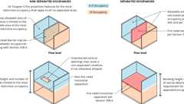
Non Separated vs. Separated Occ.
CA Nonseparated Occupancies 1
CA Nonseparated Occupancies 2
506.2.1 Single-Occupancy Buildings
Diagram
The allowable area of each story of a single-occupancy building shall be determined in accordance with Equation 5-1:
Equation 5-1
where:
A_{a} = Allowable area (square feet).
A_{t} = Tabular allowable area factor (NS, S1, S13R or S13D value, as applicable) in accordance with Table 506.2.
NS = Tabular allowable area factor in accordance with Table 506.2 for nonsprinklered building (regardless of whether the building is sprinklered).
I_{f} = Area factor increase due to frontage (percent) as calculated in accordance with Section 506.3.
The allowable area per story of a single-occupancy building with a maximum of two stories above grade plane shall be determined by Equation 5-1. The total allowable area of a single-occupancy building more than two stories above grade plane shall be determined in accordance with Equation 5-2:
(Equation 5-2)
where:
A_{a} = Allowable area (square feet).
A_{t} = Tabular allowable area factor (NS, S13R, S13D or SM value, as applicable) in accordance with Table 506.2.
NS = Tabular allowable area factor in accordance with Table 506.2 for a nonsprinklered building (regardless of whether the building is sprinklered).
I_{f} = Area factor increase due to frontage (percent) as calculated in accordance with Section 506.3.
S_{a} = 3 for other than Group A, E, H, I, L and R occupancies, high-rise buildings, and other applications listed in Section 1.11 regulated by the Office of the State Fire Marshal, where the actual number of stories above grade plane exceeds three.
S_{a} = 2 for Group A, E, H, I, L and R occupancies, high-rise buildings, and other applications listed in Section 1.11 regulated by the Office of the State Fire Marshal, actual number of building stories above grade plane, not to exceed two.
The actual area of any individual floor shall not exceed the allowable area per Equation 5-1.
UpCodes Diagram (1)
Story Above Grade Plane
506.2.2 Mixed-Occupancy Buildings
Diagram
The allowable area of each story of a mixed-occupancy building shall be determined in accordance with the applicable provisions of Section 508.3.2 for nonseparated occupancies and Section 508.4.2 for separated occupancies.
For buildings with more than two stories above grade plane, the total building area shall be such that the aggregate sum of the ratios of the actual area of each story divided by the allowable area of such stories, determined in accordance with Equation 5-3 based on the applicable provisions of Section 508.1, shall not exceed three, provided the aggregate sum of the ratios for portions of mixed-occupancy, multistory buildings containing A, E, H, I, L and R occupancies, high-rise buildings, and other applications listed in Section 1.11 regulated by the Office of the State Fire Marshal, including any other associated non-separated occupancies, shall not exceed two.
Equation 5-3
where:
A_{a} = Allowable area (square feet).
A_{t} = Tabular allowable area factor (NS, S13R, S13D or SM value, as applicable) in accordance with Table 506.2.
NS = Tabular allowable area factor in accordance with Table 506.2 for a nonsprinklered building, regardless of whether the building is sprinklered.
I_{f} = Area factor increase due to frontage (percent) as calculated in accordance with Section 506.3.
UpCodes Diagrams (4)
Story Above Grade Plane
CA Nonseparated Occupancies 1
CA Nonseparated Occupancies 2
CA Separated Occupancies 1
506.2.2.1 Group H-2 or H-3 Mixed Occupancies
For a building containing Group H-2 or H-3 occupancies, the allowable area shall be determined in accordance with Section 508.4.2, with the automatic sprinkler system increase applicable only to the portions of the building not classified as Group H-2 or H-3.
506.3 Frontage Increase
Diagram
Every building shall adjoin or have access to a public way to receive an area factor increase based on frontage. Area factor increase shall be determined in accordance with Sections 506.3.1 through 506.3.3.
UpCodes Diagram (1)
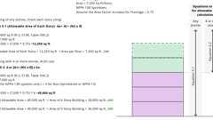
Single Occupancy, Multistory Area Calculation (2021)
506.3.1 Minimum Percentage of Perimeter
To qualify for an area factor increase based on frontage, a building shall have not less than 25 percent of its perimeter on a public way or open space. Such open space shall be either on the same lot or dedicated for public use and shall be accessed from a street or approved fire lane.
506.3.2 Minimum Frontage Distance
To qualify for an area factor increase based on frontage, the public way or open space adjacent to the building perimeter shall have a minimum distance of 20 feet (6096 mm) measured at right angles from the building face to any of the following:
- The closest interior lot line.
- The entire width of a street, alley or public way.
- The exterior face of an adjacent building on the same property.
The frontage increase shall be based on the smallest public way or open space that is 20 feet (6096 mm) or greater, and the percentage of building perimeter having a minimum 20 feet (6096 mm) public way or open space.
506.3.3 Amount of Increase
The area factor increase based on frontage shall be determined in accordance with Table 506.3.3.
TABLE 506.3.3—FRONTAGE INCREASE FACTORª
PERCENTAGE OF  BUILDING PERIMETER | OPEN SPACE (feet)
PERCENTAGE OF  BUILDING PERIMETER | 20 to less than 25 | 25 to less than 30 | 30 or greater
0 to less than 25 | 0 | 0 | 0
25 to less than 50 | 0.17 | 0.21 | 0.25
50 to less than 75 | 0.33 | 0.42 | 0.50
75 to 100 | 0.50 | 0.63 | 0.75
For SI: 1 foot = 304.8 mm.
- Interpolation is permitted.
506.3.3.1 Section 507 Buildings
Where a building meets the requirements of Section 507, as applicable, except for compliance with the minimum 60-foot (18 288 mm) public way or yard requirement, the area factor increase based on frontage shall be determined in accordance with Table 506.3.3.1. The frontage increase shall be based on the smallest public way or open space that is 30 feet (9144 mm) or greater, and the percentage of building perimeter having a minimum 30 feet (9144 mm) public way or open space.
TABLE 506.3.3.1—SECTION 507 BUILDINGSª
PERCENTAGE OF  BUILDING  PERIMETER | OPEN SPACE (feet)
PERCENTAGE OF  BUILDING  PERIMETER | 30 to less than 35 | 35 to less than 40 | 40 to less than 45 | 45 to less than 50 | 50 to less than 55 | 55 or greater
0 to less than 25 | 0 | 0 | 0 | 0 | 0 | 0
25 to less than 50 | 0.29 | 0.33 | 0.38 | 0.42 | 0.46 | 0.50
50 to less than 75 | 0.58 | 0.67 | 0.75 | 0.83 | 0.92 | 1.00
75 to 100 | 0.88 | 1.00 | 1.13 | 1.25 | 1.38 | 1.50
For SI:For SI: 1 foot = 304.8 mm.
- Interpolation is permitted.
Section 507 Unlimited Area Buildings
Diagram
UpCodes Diagrams (5)
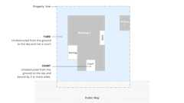
Yards and Courts
Open Spaces for Unlimited Area Bldgs.
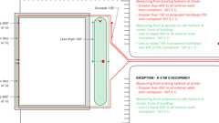
Fire Hydrant Systems (CFC)
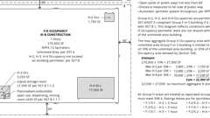
Unlimited Bldg Area: Group H-2, H-3 and H-4 Occs.
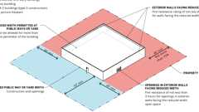
Unlimited Area Buildings: Reduced Open Space
Building product (1)
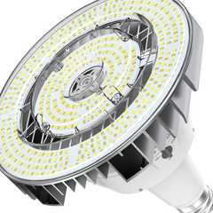
High Bay Bluetooth-enabled
RAB Lighting

507.1 General
The area of buildings of the occupancies and configurations specified in Sections 507.1 through 507.13 shall not be limited. Basements not more than one story below grade plane shall be permitted.
507.1.1 Accessory Occupancies
Diagram
Accessory occupancies shall be permitted in unlimited area buildings in accordance with the provisions of Section 508.2, otherwise the requirements of Sections 507.3 through 507.13 shall be applied, where applicable.
UpCodes Diagrams (2)
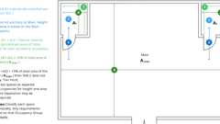
Accessory Occupancies
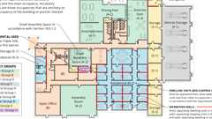
Multiple Occupancy Building: Non-Separated Occupancy Requirements
507.2 Measurement of Open Spaces
Diagram
Where Sections 507.3 through 507.13 require buildings to be surrounded and adjoined by public ways and yards, those open spaces shall be determined as follows:
- Yards shall be measured from the building perimeter in all directions to the closest interior lot lines or to the exterior face of an opposing building located on the same lot, as applicable.
- Where the building fronts on a public way, the entire width of the public way shall be used.
UpCodes Diagram (1)
Primary
Open Spaces for Unlimited Area Bldgs.
507.2.1 Reduced Open Space
Diagram
The public ways or yards of 60 feet (18 288 mm) in width required in Sections 507.3, 507.4, 507.5, 507.6 and 507.12 shall be permitted to be reduced to not less than 40 feet (12 192 mm) in width, provided that the following requirements are met:
- The reduced width shall not be allowed for more than 75 percent of the perimeter of the building.
- The exterior walls facing the reduced width shall have a fire-resistance rating of not less than 3 hours.
- Openings in the exterior walls facing the reduced width shall have opening protectives with a fire protection rating of not less than 3 hours.
UpCodes Diagram (1)
Primary
Unlimited Area Buildings: Reduced Open Space
507.3 Nonsprinklered, One-Story Buildings
Diagram
The area of a Group F-2 or S-2 building of any construction type not more than one story above grade plane shall not be limited where the building is surrounded and adjoined by public ways or yards not less than 60 feet (18 288 mm) in width.
UpCodes Diagram (1)
Unlimited Area Buildings: Reduced Open Space
507.4 Sprinklered, One-Story Buildings
The area of a Group A-4 building not more than one story above grade plane of other than Type V construction, or the area of a Group B, F, M or S building no more than one story above grade plane of any construction type, shall not be limited where the building is provided with an automatic sprinkler system throughout in accordance with Section 903.3.1.1 and is surrounded and adjoined by public ways or yards not less than 60 feet (18 288 mm) in width.
Exceptions:
- Buildings and structures of Type I or II construction for rack storage facilities that do not have access by the public shall not be limited in height, provided that such buildings conform to the requirements of Sections 507.4 and 903.3.1.1 and Chapter 32 of the California Fire Code.
- The automatic sprinkler system shall not be required in areas occupied for indoor participant sports, such as tennis, skating, swimming and equestrian activities in occupancies in Group A-4, provided that the following criteria are met:
  - 2.1. Exit doors directly to the outside are provided for occupants of the participant sports areas.
  - 2.2. The building is equipped with a fire alarm system with manual fire alarm boxes installed in accordance with Section 907.
  - 2.3. An automatic sprinkler system is provided in storage rooms, press boxes, concession booths or other spaces ancillary to the sport activity space.
Building product (1)
High Bay Bluetooth-enabled
RAB Lighting

507.4.1 Mixed Occupancy Buildings With Groups A-1 and A-2
Group A-1 and A-2 occupancies of other than Type V construction shall be permitted within mixed occupancy buildings of unlimited area complying with Section 507.4, provided that the following criteria are met:
- Group A-1 and A-2 occupancies are separated from other occupancies as required for separated occupancies in Section 508.4.4 with no reduction allowed in the fire-resistance rating of the separation based upon the installation of an automatic sprinkler system.
- Each area of the portions of the building used for Group A-1 or A-2 occupancies shall not exceed the maximum allowable area permitted for such occupancies in Section 503.1.
- Exit doors from Group A-1 and A-2 occupancies shall discharge directly to the exterior of the building.
507.5 Two-Story Buildings
Diagram
The area of a Group B, F, M or S building not more than two stories above grade plane shall not be limited where the building is equipped throughout with an automatic sprinkler system in accordance with Section 903.3.1.1 and is surrounded and adjoined by public ways or yards not less than 60 feet (18 288 mm) in width.
UpCodes Diagram (1)
Unlimited Area Buildings: Reduced Open Space
507.6 Group A-3 Buildings of Type II Construction
Diagram
The area of a Group A-3 building not more than one story above grade plane, used as a place of religious worship, community hall, dance hall, exhibition hall, gymnasium, lecture hall, indoor swimming pool or tennis court of Type II construction, shall not be limited provided that the following criteria are met:
- The building shall not have a stage other than a platform.
- The building shall be equipped throughout with an automatic sprinkler system in accordance with Section 903.3.1.1.
- The building shall be surrounded and adjoined by public ways or yards not less than 60 feet (18 288 mm) in width.
UpCodes Diagram (1)
Unlimited Area Buildings: Reduced Open Space
507.7 Group A-3 Buildings of Type III and IV Construction
The area of a Group A-3 building of Type III or IV construction, with not more than one story above grade plane and used as a place of religious worship, community hall, dance hall, exhibition hall, gymnasium, lecture hall, indoor swimming pool or tennis court, shall not be limited provided that the following criteria are met:
- The building shall not have a stage other than a platform.
- The building shall be equipped throughout with an automatic sprinkler system in accordance with Section 903.3.1.1.
- The assembly floor shall be located 21 inches (533 mm) or less from street or grade level and all exits are provided with ramps complying with Section 1012 to the street or grade level.
- The building shall be surrounded and adjoined by public ways or yards not less than 60 feet (18 288 mm) in width.
507.8 Group H-2, H-3 and H-4 Occupancies
Diagram
Group H-2, H-3 and H-4 occupancies shall be permitted in unlimited area buildings containing Group F or S occupancies in accordance with Sections 507.4 and 507.5 and the provisions of Sections 507.8.1 through 507.8.4.
UpCodes Diagrams (2)
Primary
Unlimited Bldg Area: Group H-2, H-3 and H-4 Occs.
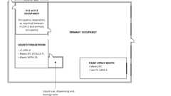
Unlimited Area Exception: Group H
507.8.1 Allowable Area
The aggregate floor area of Group H occupancies located in an unlimited area building shall not exceed 10 percent of the area of the building or the area limitations for the Group H occupancies as specified in Section 506 based on the perimeter of each Group H floor area that fronts on a public way or open space.
507.8.1.1 Located Within the Building
Diagram
The aggregate floor area of Group H occupancies not located at the perimeter of the building shall not exceed 25 percent of the area limitations for the Group H occupancies as specified in Section 506.
UpCodes Diagram (1)
Unlimited Bldg Area: Group H-2, H-3 and H-4 Occs.
507.8.1.1.1 Rooms for Flammable or Combustible Liquid Use, Dispensing or Mixing in Open Systems
Rooms for flammable or combustible liquid use, dispensing or mixing in open systems having a floor area of not more than 500 square feet (46.5 m²) need not be located on the outer perimeter of the building where they are in accordance with the California Fire Code and NFPA 30.
507.8.1.1.2 Liquid Storage Rooms and Rooms for Flammable or Combustible Liquid Use in Closed Systems
Liquid storage rooms and rooms for flammable or combustible liquid use in closed systems having a floor area of not more than 1,000 square feet (93 m²) need not be located on the outer perimeter where they are in accordance with the California Fire Code and NFPA 30.
507.8.1.1.3 Spray Paint Booths
Spray paint booths that comply with the California Fire Code need not be located on the outer perimeter.
507.8.2 Located on Building Perimeter
Diagram
Except as provided for in Section 507.8.1.1, Group H occupancies shall be located on the perimeter of the building. In Group H-2 and H-3 occupancies, not less than 25 percent of the perimeter of such occupancies shall be an exterior wall.
UpCodes Diagram (1)
Unlimited Bldg Area: Group H-2, H-3 and H-4 Occs.
507.8.3 Occupancy Separations
Group H occupancies shall be separated from the remainder of the unlimited area building and from each other in accordance with Table 508.4.
507.8.4 Height Limitations
For two-story, unlimited area buildings, Group H occupancies shall not be located more than one story above grade plane unless permitted based on the allowable height and number of stories and feet as specified in Section 504 based on the type of construction of the unlimited area building.
507.9 Unlimited Mixed Occupancy Buildings With Group H-5
Assembly
The area of a Group B, F, H-5, M or S building not more than two stories above grade plane shall not be limited where the building is equipped throughout with an automatic sprinkler system in accordance with Section 903.3.1.1, and is surrounded and adjoined by public ways or yards not less than 60 feet (18 288 mm) in width, provided that the following criteria are met:
- Buildings containing Group H-5 occupancy shall be of Type I or II construction.
- Each area used for Group H-5 occupancy shall be separated from other occupancies as required in Sections 415.11 and 508.4.
- Each area used for Group H-5 occupancy shall not exceed the maximum allowable area permitted for such occupancies in Section 503.1 including modifications of Section 506.
Exception: Where the Group H-5 occupancy exceeds the maximum allowable area, the Group H-5 shall be subdivided into areas that are separated by 2-hour fire barriers.
Assemblies (8)
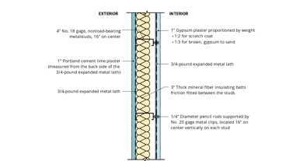
15-1.9: 2hr, Steel Stud
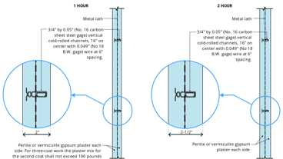
6-1.2: 1hr & 2hr, Solid Gyp Plaster
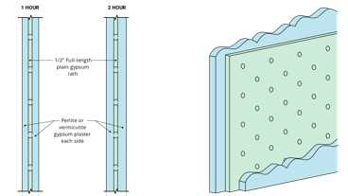
6-2.2: 1hr & 2hr, Solid Gyp
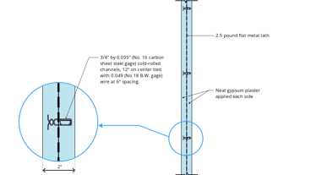
8-1.1: 2hr, Steel
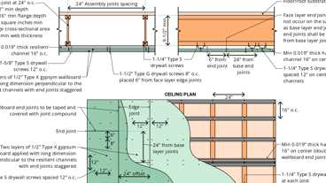
30-1.1: 2hr, I-joist
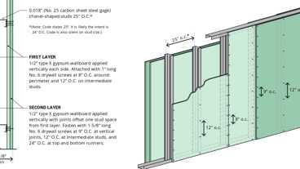
13-1.2: 2hr, Steel Studs
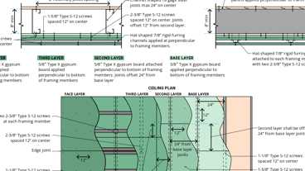
29-1.1: 2-hr, Steel
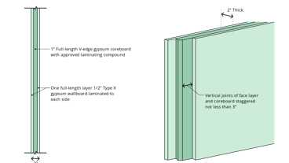
9-1.1: 2hr, Solid Wallboard
507.10 Aircraft Paint Hangar
Diagram
The area of a Group H-2 aircraft paint hangar not more than one story above grade plane shall not be limited where such aircraft paint hangar complies with the provisions of Section 412.5 and is surrounded and adjoined by public ways or yards not less in width than one and one-half times the building height.
UpCodes Diagrams (2)
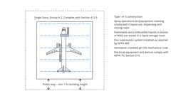Primary
Unlimited Area Paint Hangers
Unlimited Area Aircraft Bldgs.
507.11 Group E Buildings
The area of a Group E building not more than one story above grade plane, of Type II, IIIA or IV construction, shall not be limited provided that the following criteria are met:
- Each classroom shall have not less than two means of egress, with one of the means of egress being a direct exit to the outside of the building complying with Section 1022.
- The building is equipped throughout with an automatic sprinkler system in accordance with Section 903.3.1.1.
- The building is surrounded and adjoined by public ways or yards not less than 60 feet (18 288 mm) in width.
507.12 Motion Picture Theaters
Diagram
In buildings of Type II construction, the area of a motion picture theater located on the first story above grade plane shall not be limited where the building is provided with an automatic sprinkler system throughout in accordance with Section 903.3.1.1 and is surrounded and adjoined by public ways or yards not less than 60 feet (18 288 mm) in width.
UpCodes Diagram (1)
Unlimited Area Buildings: Reduced Open Space
507.13 Covered and Open Mall Buildings and Anchor Buildings
The area of covered and open mall buildings and anchor buildings not exceeding three stories in height that comply with Section 402 shall not be limited.
Section 508 Mixed Use and Occupancy
Diagram
UpCodes Diagrams (2)
Non Separated vs. Separated Occ.
Accessory Occupancies
508.1 General
Each portion of a building shall be individually classified in accordance with Section 302.1. Where a building contains more than one occupancy group, the building or portion thereof shall comply with the applicable provisions of Section 508.2, 508.3, 508.4 or 508.5, or a combination of these sections.
Exceptions:
- Occupancies separated in accordance with Section 510.
- Where required by Table 415.6.5, areas of Group H-1, H-2 and H-3 occupancies shall be located in a detached building or structure.
508.2 Accessory Occupancies
Diagram
Accessory occupancies are those occupancies that are ancillary to the main occupancy of the building or portion thereof. Accessory occupancies shall comply with the provisions of Sections 508.2.1 through 508.2.4.
UpCodes Diagrams (4)
Primary
Multiple Occupancy Building: Non-Separated Occupancy Requirements
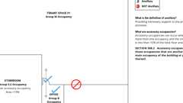Primary
Accessory Occ.: Example
Primary
Accessory Occupancies
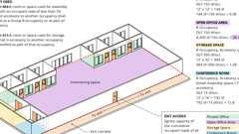
Cumulative Occ. Loads: Intervening Spaces/Accessory Areas
508.2.1 Occupancy Classification
Diagram
Accessory occupancies shall be individually classified in accordance with Section 302.1. The requirements of this code shall apply to each portion of the building based on the occupancy classification of that space.
UpCodes Diagram (1)
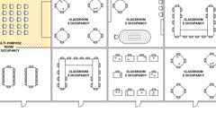
Edu. Accessory to Group A
508.2.2 Allowable Building Height
Diagram
The allowable height and number of stories of the building containing accessory occupancies shall be in accordance with Section 504 for the main occupancy of the building.
UpCodes Diagram (1)
Building Height Measurements
508.2.3 Allowable Building Area
The allowable area of the building shall be based on the applicable provisions of Section 506 for the main occupancy of the building. Aggregate accessory occupancies shall not occupy more than 10 percent of the floor area of the story in which they are located and shall not exceed the tabular values for nonsprinklered buildings in Table 506.2 for each such accessory occupancy.
508.2.4 Separation of Occupancies
No separation is required between accessory occupancies and the main occupancy.
Exceptions:
- Group H-2, H-3, H-4 and H-5 and L occupancies shall be separated from all other occupancies in accordance with Section 508.4.
- Group R-1, R-2, R-2.1, R-2.2 and R-3 dwelling units and sleeping units shall be separated from other dwelling or sleeping units and from accessory occupancies contiguous to them in accordance with the requirements of Section 420.
- Group I-2 shall be separated from all other occupancies in accordance with Section 508.4.
Exception: No separation is required between Group B, E and R-1 sleeping units accessory to Group I-2 and covered exterior entrances required by Section 11B-206.4.10 or Section 1224.33.2.1 accessory to Group I-2.
- Group I-3 shall be separated from all other occupancies in accordance with Section 508.4.
508.3 Nonseparated Occupancies
Diagram
Buildings or portions of buildings that comply with the provisions of this section shall be considered as nonseparated occupancies.
UpCodes Diagram (1)
Primary
Non Separated vs. Separated Occ.
508.3.1 Occupancy Classification
Diagram
Nonseparated occupancies shall be individually classified in accordance with Section 302.1. The requirements of this code shall apply to each portion of the building based on the occupancy classification of that space. In addition, the most restrictive provisions of Chapter 9 that apply to the nonseparated occupancies shall apply to the total nonseparated occupancy area.
UpCodes Diagram (1)
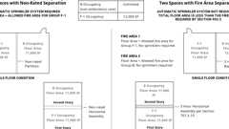
Fire Areas: Multi. Occ., Non-Rated vs. Rated Separation
508.3.1.1 High-Rise Buildings
Where nonseparated occupancies occur in a high-rise building, the most restrictive requirements of Section 403 that apply to the nonseparated occupancies shall apply throughout the high-rise building.
508.3.1.2 Group I-2, Condition 2 Occupancies
Where one of the nonseparated occupancies is Group I-2, Condition 2, the most restrictive requirements of Sections 407, 509 and 712 shall apply throughout the fire area containing the Group I-2 occupancy. The most restrictive requirements of Chapter 10 shall apply to the path of egress from the Group I-2, Condition 2 occupancy up to and including the exit discharge.
508.3.2 Allowable Building Area, Height and Number of Stories
Diagram
The allowable building area, height and number of stories of the building or portion thereof shall be based on the most restrictive allowances for the occupancy groups under consideration for the type of construction of the building in accordance with Section 503.1.
UpCodes Diagrams (3)
Primary
CA Nonseparated Occupancies 2
Primary
CA Nonseparated Occupancies 1
Building Height on Sloping Site
508.3.3 Separation
No separation is required between nonseparated occupancies.
Exceptions:
- Group H-2, H-3, H-4 and H-5, I-2 and L occupancies shall be separated from all other occupancies in accordance with Section 508.4.
- Group R-1, R-2, R-2.1, R-2.2 and R-3 dwelling units and sleeping units shall be separated from other dwelling or sleeping units and from other occupancies contiguous to them in accordance with the requirements of Section 420.
- Where Group I-3 is not the main occupancy and the area is greater than 10 percent of the floor area, it shall be separated per Table 508.4.
508.4 Separated Occupancies
Diagram
Buildings or portions of buildings that comply with the provisions of this section shall be considered as separated occupancies.
TABLE 508.4—REQUIRED SEPARATION OF OCCUPANCIES (HOURS)^{f}
OCCUPANCY | A, E |  | I-4^{i}, R-2.1 |  | I-2^{j} |  | I-3 |  | R-1ª, R-2ª,  R-2.2ª,  R-3ª, R-3.1ª,  R-4ª |  | F-2, S-2^{b},  U |  | B^{e}, F-1^{g, h},  M, S-1 |  | L |  | H-1 |  | H-2 |  | H-3, H-4 |  | H-5
OCCUPANCY | S | NS | S | NS | S | NS | S | NS | S | NS | S | NS | S | NS | S | NS | S | NS | S | NS | S | NS | S | NS
A, E | N | N | 1 | 2 | 2 | NP | 2 | NP | 1 | 2 | N | 1 | 1 | 2 | 2 | NP | NP | NP | 3 | 4 | 2 | 3 | 2 | NP
I-4^{i}, R-2.1 | 1 | 2 | N | N | 2 | NP | 2 | NP | 1 | NP | 1 | 2 | 1 | 2 | 2 | NP | NP | NP | 4 | NP | 2 | NP | 4 | NP
I-2^{j} | 2 | NP | 2 | NP | N | N | 2 | NP | 2 | NP | 2 | NP | 2 | NP | 2 | NP | NP | NP | 4 | NP | 2 | NP | 4 | NP
I-3 | 2 | NP | 2 | NP | 2 | NP | N | NP | 2 | NP | 2 | 2 | 2 | 2 | 2 | NP | NP | NP | 4 | NP | 4 | NP | 4 | NP
R-1ª, R-2ª,  R-2.2ª, R-3ª,  R-3.1ª, R-4ª | 1 | 2 | 1 | NP | 2 | NP | 2 | NP | N | N | 1^{c} | 2^{c} | 1 | 2 | 4 | NP | NP | NP | 3 | NP | 2 | NP | 2 | NP
F-2, S-2^{b}, U | N | 1 | 1 | 2 | 2 | NP | 2 | 2 | 1^{c} | 2^{c} | N | N | 1 | 2 | 1 | NP | NP | NP | 3 | 4 | 2 | 3 | 2 | NP
B^{e}, F-1^{g, h}, M, S-1 | 1 | 2 | 1 | 2 | 2 | NP | 2 | 2 | 1 | 2 | 1 | 2 | N | N | 1 | NP | NP | NP | 2 | 3 | 1 | 2 | 1 | NP
L | 2 | NP | 2 | NP | 2 | NP | 2 | NP | 4 | NP | 1 | NP | 1 | NP | 1 | NP | NP | NP | 2 | NP | 1 | NP | 1 | NP
H-1 | NP | NP | NP | NP | NP | NP | NP | NP | NP | NP | NP | NP | NP | NP | NP | NP | N | NP | NP | NP | NP | NP | NP | NP
H-2 | 3 | 4 | 4 | NP | 4 | NP | 4 | NP | 3 | 4 | 3 | 4 | 2 | 3 | 2 | NP | NP | NP | N | NP | 1 | NP | 1 | NP
H-3, H-4 | 2 | 3 | 4 | NP | 4 | NP | 4 | NP | 2 | 3 | 2 | 3 | 1 | 2 | 1 | NP | NP | NP | 1 | NP | 1^{d} | NP | 1 | NP
H-5 | 2 | NP | 4 | NP | 4 | NP | 4 | NP | 2 | NP | 2 | NP | 1 | NP | 1 | NP | NP | NP | 1 | NP | 1 | NP | N | NP
S = Buildings equipped throughout with an automatic sprinkler system installed in accordance with Section 903.3.1.1.
NS = Buildings not equipped throughout with an automatic sprinkler system installed in accordance with Section 903.3.1.1.
N = No separation requirement.
NP = Not Permitted.
- See Section 420.
- The required separation from areas used only for private or pleasure vehicles shall be reduced by 1 hour but not to less than 1 hour.
- See Sections 406.3.2 and 406.6.4.
- Separation is not required between occupancies of the same classification.
- See Section 422.2 for ambulatory care facilities.
- Occupancy separations that serve to define fire area limits established in Chapter 9 for requiring fire protection systems shall also comply with Section 707.3.10 and Table 707.3.10 in accordance with Section 901.7.
- [SFM] Group I and F1 occupancies and Group R-2.1 and F-1 occupancies shall have a 3 hour separation.
- [SFM] Commercial kitchens not associated with cafeterias and similar dining facilities in Group I-2 and Group R-2.1 shall have a 2-hour separation and shall be protected by an automatic sprinkler system.
- [SFM] Group E child-care separation with I-4 child care can be reduced to 1 hour with the installation of automatic fire sprinklers in accordance with Section 903.3.1.1.
- When not considered an accessory use in accordance with Section 508.2.4, the required separation between Group I-2 and required covers for accessible entrances and emergency vehicle entrances, when in accordance with Section 406.5.2 and protected by an automatic sprinkler system, shall be reduced by 1 hour but not to less than 1 hour. See Section 903.2.21.
UpCodes Diagrams (7)
Primary
CA Separated Occupancies 1
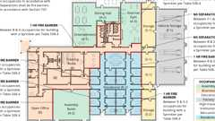Primary
Multiple Occupancy Building: Separated Occupancy Requirements
Primary
Non Separated vs. Separated Occ.
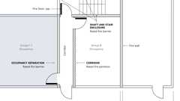
Fire Rated Wall Assemblies
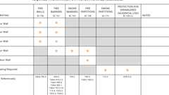
Required Fire Ratings for Protective Wall Assemblies
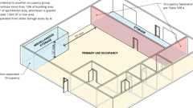
Miscellaneous Storage
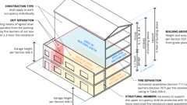
Open Parking Garage Beneath Groups A, I, B, M and R
Building products (8)
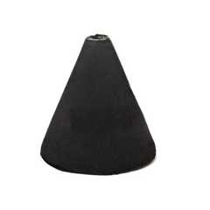
FF109-200 1 Hour Fire Rated LED Downlight Cover
Tenmat

FF109-250 1 Hour Fire Rated LED Downlight Cover
Tenmat

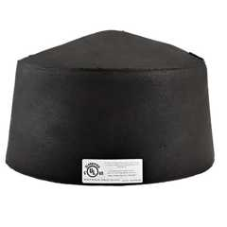
FF109-300 UL Fire Rated Recessed Light Cover
Tenmat

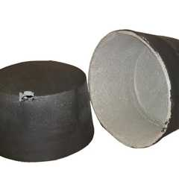
FF109-350 Fire Rated Light Cover
Tenmat

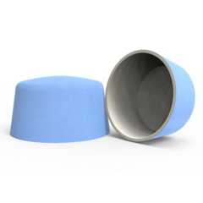
FF109-FRSC 1 Hour Fire Rated Speaker Cover
Tenmat

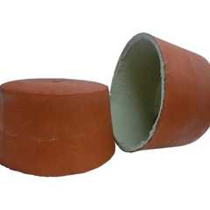
FF109X 2 Hour UL Fire Rated Recessed Light Cover
Tenmat

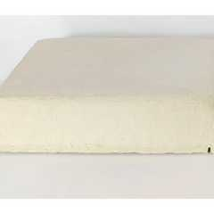
FF130 - 2x2 Fire Rated Troffer Cover
Tenmat

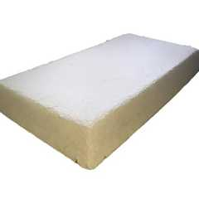
FF130 - 2x4 Fire Rated Troffer Cover
Tenmat

508.4.1 Occupancy Classification
Diagram
Separated occupancies shall be individually classified in accordance with Section 302.1. Each separated space shall comply with this code based on the occupancy classification of that portion of the building. The most restrictive provisions of Chapter 9 that apply to the separate occupancies shall apply to the total nonfire-barrier-separated occupancy areas. Occupancy separations that serve to define fire area limits established in Chapter 9 for requiring a fire protection system shall also comply with Section 901.7.
UpCodes Diagram (1)
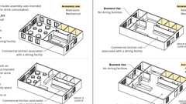
Commercial Kitchens: Occupancy
508.4.2 Allowable Building Area
Diagram
In each story, the building area shall be such that the sum of the ratios of the actual building area of each separated occupancy divided by the allowable building area of each separated occupancy shall not exceed 1.
UpCodes Diagram (1)
Building Area (Definition)
508.4.3 Allowable Building Height and Number of Stories
Diagram
Each separated occupancy shall comply with the building height limitations and story limitations based on the type of construction of the building in accordance with Section 503.1.
Exception: Special provisions of Section 510 shall permit occupancies at building heights and number of stories other than provided in Section 503.1.
UpCodes Diagrams (3)
Podiums: Type IIIA Height Increase (2021)
Building Height on Sloping Site
Podiums: Parking Beneath Group R
508.4.4 Separation
Assembly
Individual occupancies shall be separated from adjacent occupancies in accordance with Table 508.4.
Assemblies (8)
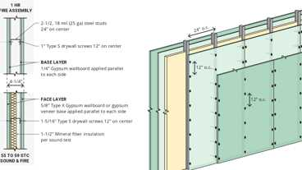
WP 1015: 1hr, 55-59 STC, Steel Stud
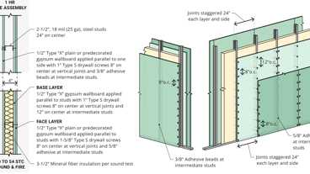
WP 1021: 1hr, 50-54 STC, Steel Stud
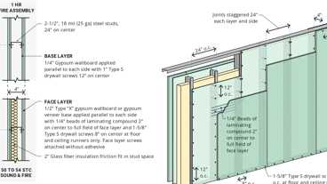
WP 1051: 1hr, 50-54 STC, Steel Stud
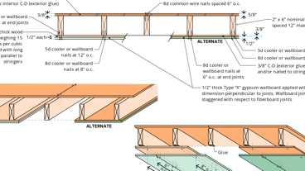
14-1.1: 1hr, Wood Joist
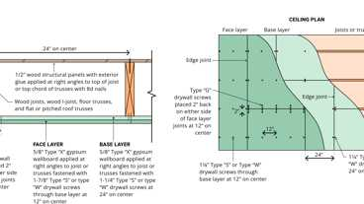
21-1.1: 1hr, Wood Joist
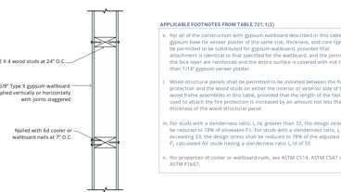
14-1.3: 1hr, Wood
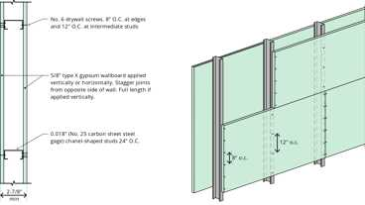
13-1.1: 1hr Steel Studs
13-1.2: 2hr, Steel Studs
508.4.4.1 Construction
Required separations shall be fire barriers constructed in accordance with Section 707 or horizontal assemblies constructed in accordance with Section 711, or both, so as to completely separate adjacent occupancies. Mass timber elements serving as fire barriers or horizontal assemblies to separate occupancies in Type IV-B or IV-C construction shall be separated from the interior of the building with an approved thermal barrier consisting of gypsum board that is not less than ¹/₂ inch (12.7 mm) in thickness or a material that is tested in accordance with and meets the acceptance criteria of both the Temperature Transmission Fire Test and the Integrity Fire Test of NFPA 275.
Exception: A thermal barrier shall not be required on the top of horizontal assemblies serving as occupancy separations.
Building products (9)
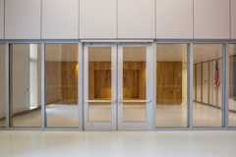
GPX® Ballistic
SaftiFirst

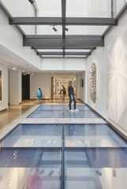
GPX® FireFloor
SaftiFirst

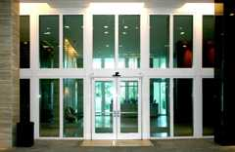
GPX® Hurricane
SaftiFirst

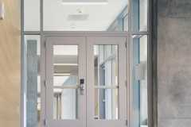
SuperLite® II-XL 60
SaftiFirst


SuperLite® II-XL 90
SaftiFirst

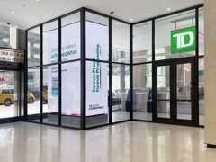
SuperLite® II-XLB 120
SaftiFirst

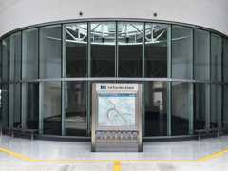
SuperLite® II-XLB 60
SaftiFirst


SuperLite® II-XLM 120
SaftiFirst

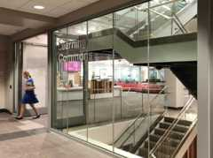
SuperLite® II-XLM 60
SaftiFirst

508.5 Live/Work Units
Live/work units shall comply with one of the following:
- For a live/work unit located in a building constructed in accordance with this code, both the residential and nonresidential portions of the live/work unit shall comply with Sections 508.5 through 508.5.11.
- For a live/work unit located in a building constructed in accordance with the California Residential Code, the nonresidential portion of the live/work unit shall comply with Sections 508.5.1 through 508.5.11, and the residential portion of the live/work unit shall be constructed in accordance with the California Residential Code and Section 508.5.7.
Exceptions:
- Dwelling or sleeping units that include an office that is less than 10 percent of the area of the dwelling unit are permitted to be classified as dwelling units with accessory occupancies in accordance with Section 508.2.
- Live/work units complying with the requirements of Section 508.5 shall be permitted to be constructed as one- and two-family dwellings or townhouses in accordance with the California Residential Code, as applicable.
508.5.1 Limitations
The following shall apply to live/work areas:
- The live/work unit is permitted to be not greater than 3,000 square feet (279 m²) in area.
- The nonresidential area is permitted to be not more than 50 percent of the area of each live/work unit.
- The nonresidential area function shall be limited to the first or main floor only of the live/work unit.
508.5.2 Occupancies
Live/work units shall be classified as a Group R-2 occupancy. Separation requirements found in Sections 420 and 508 shall not apply within the live/work unit where the live/work unit is in compliance with Section 508.5. Nonresidential uses that would otherwise be classified as either a Group H or S occupancy shall not be permitted in a live/work unit.
Exception: Storage shall be permitted in the live/work unit provided that the aggregate area of storage in the nonresidential portion of the live/work unit shall be limited to 10 percent of the space dedicated to nonresidential activities.
[BE] 508.5.3 Means of Egress
Except as modified by this section, the means of egress components for a live/work unit shall be designed in accordance with Chapter 10 for the function served.
Exception: Residential areas of live/work units constructed in accordance with the California Residential Code shall not be required to comply with Chapter 10.
[BE] 508.5.4 Egress Capacity
The egress capacity for each element of the live/work unit shall be based on the occupant load for the function served in accordance with Table 1004.5.
[BE] 508.5.5 Spiral Stairways
Spiral stairways that conform to the requirements of Section 1011.10 shall be permitted.
[BE] 508.5.6 Vertical Openings
Floor openings between floor levels of a live/work unit are permitted without enclosure.
[F] 508.5.7 Fire Protection
Live/work units in buildings constructed in accordance with this code shall be provided with all of the following:
- An automatic sprinkler system in accordance with Section 903.3.1.1 or 903.3.1.2.
- Smoke alarms in accordance with Section 907.2.11.
- Where required by Section 907.2.9.2, a manual fire alarm system.
Live/work units in buildings constructed in accordance with the California Residential Code shall be provided with an automatic sprinkler system and smoke alarms. The automatic sprinkler system shall comply with California Residential Code Section R309, and smoke alarms shall comply with California Residential Code Section 310.
508.5.8 Structural
Floors within a live/work unit shall be designed for the live loads in Table 1607.1, based on the function within the space.
Exception: Residential areas of live/work units constructed in accordance with the California Residential Code shall not be required to comply with Table 1607.1.
[BE] 508.5.9 Accessibility
Accessibility shall be designed in accordance with Chapter 11A and/or 11B, when applicable, for the function served.
508.5.10 Ventilation
The applicable ventilation requirements of the California Mechanical Code shall apply to each area within the live/work unit for the function within that space.
508.5.11 Plumbing Facilities
The nonresidential area of the live/work unit shall be provided with minimum plumbing facilities as specified by the California Plumbing Code, based on the function of the nonresidential area. Where the nonresidential area of the live/work unit is required to be accessible, the plumbing fixtures specified by the California Plumbing Code shall be accessible.
Section 509 Incidental Uses
509.1 General
Diagram
Incidental uses located within single occupancy or mixed occupancy buildings shall comply with the provisions of this section. Incidental uses are ancillary functions associated with a given occupancy that generally pose a greater level of risk to that occupancy and are limited to those uses specified in Table 509.1.
Exception: Incidental uses within and serving a dwelling unit are not required to comply with this section.
[F] TABLE 509.1—INCIDENTAL USES
ROOM OR AREA | SEPARATION AND/OR PROTECTION
Furnace room where any piece of equipment is over 400,000 Btu per hour input | 1 hour or provide automatic sprinkler system
Rooms with boilers where the largest piece of equipment is over 15 psi and 10 horsepower | 1 hour or provide automatic sprinkler system
Refrigerant machinery room | 1 hour or provide automatic sprinkler system
Hydrogen fuel gas rooms, not classified as Group H | 1 hour in Group B, F, M, S and U occupancies; 2 hours in Group A, E, I and R occupancies.
Incinerator rooms | 2 hours and provide automatic sprinkler system
Paint shops, not classified as Group H, located in occupancies other than Group F | 2 hours; or 1 hour and provide automatic sprinkler system
In Group E occupancies, laboratories and vocational shops not classified as Group H | 1 hour or provide automatic sprinkler system
[SFM] Rooms or areas with special hazards such as laboratories, vocational shops and other such areas not classified as Group H, located in Group E occupancies where hazardous materials in quantities not exceeding the maximum allowable quantity are used or stored. | 1 hour
In Group I-2 occupancies, laboratories not classified as Group H | 1 hourª
In ambulatory care facilities, laboratories not classified as Group H | 1 hour or provide automatic sprinkler system
Laundry rooms over 100 square feet | 1 hour or provide automatic sprinkler system
In Group I-2, laundry rooms over 100 square feet | 1 hour and provide automatic sprinkler systemª
Group I-3 cells and Group I-2 patient rooms equipped with padded surfaces | 1 hour and provide automatic sprinkler systemª
In Group I-2, physical plant maintenance shops | 1 hour and provide automatic sprinkler systemª
In ambulatory care facilities or Group I-2 occupancies, waste and linen collection rooms with containers that have an aggregate volume of 8.67 cubic feet or greater | 1 hour and provide automatic sprinkler systemª
In other than ambulatory care facilities and Group I-2 occupancies, waste and linen collection rooms over 100 square feet | 1 hour or provide automatic sprinkler system
In ambulatory care facilities or Group I-2 occupancies, storage rooms greater than 50 square feet | 1 hour and provide automatic sprinkler systemª
Electrical installations and transformers | See Sections 110.26 through 110.34 and Sections 450.8 through 450.48 of the California Electrical Code for protection and separation requirements.
For SI: 1 square foot = 0.0929 m², 1 pound per square inch (psi) = 6.9 kPa, 1 British thermal unit (Btu) per hour = 0.293 watts, 1 horsepower = 746 watts, 1 gallon = 3.785 L, 1 cubic foot = 0.0283 m³.
- [SFM] Fire barrier protection and automatic sprinkler protection required throughout the fire area in I-2 occupancies as indicated.
UpCodes Diagrams (2)
Multiple Occupancy Building: Non-Separated Occupancy Requirements
Required Fire Ratings for Protective Wall Assemblies
509.2 Occupancy Classification
Incidental uses shall not be individually classified in accordance with Section 302.1. Incidental uses shall be included in the building occupancies within which they are located.
509.3 Area Limitations
Incidental uses shall not occupy more than 10 percent of the building area of the story in which they are located.
Exception: Group E laboratories that are not classified as a Group H and are separated by a 1-hour fire barrier.
509.4 Separation and Protection
Assembly
Diagram
The incidental uses specified in Table 509.1 shall be separated from the remainder of the building or equipped with an automatic sprinkler system, or both, in accordance with the provisions of that table.
UpCodes Diagram (1)
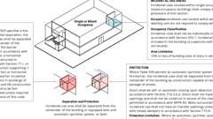
Incidental Use Areas
Assemblies (5)
14-1.1: 1hr, Wood Joist
21-1.1: 1hr, Wood Joist
14-1.3: 1hr, Wood
13-1.1: 1hr Steel Studs
13-1.2: 2hr, Steel Studs
Building products (7)
FF109-200 1 Hour Fire Rated LED Downlight Cover
Tenmat

FF109-250 1 Hour Fire Rated LED Downlight Cover
Tenmat

FF109-300 UL Fire Rated Recessed Light Cover
Tenmat

FF109-350 Fire Rated Light Cover
Tenmat

FF109-FRSC 1 Hour Fire Rated Speaker Cover
Tenmat

FF130 - 2x2 Fire Rated Troffer Cover
Tenmat

FF130 - 2x4 Fire Rated Troffer Cover
Tenmat

509.4.1 Separation
Where Table 509.1 specifies a fire-resistance-rated separation, the incidental uses shall be separated from the remainder of the building by a fire barrier constructed in accordance with Section 707 or a horizontal assembly constructed in accordance with Section 711, or both. Construction supporting 1-hour fire barriers or horizontal assemblies used for incidental use separations in buildings of Type IIB, IIIB and VB construction is not required to be fire-resistance rated unless required by other sections of this code.
Building products (3)
SuperLite® II-XL 60
SaftiFirst

SuperLite® II-XLB 60
SaftiFirst

SuperLite® II-XLM 60
SaftiFirst

509.4.1.1 Type IV-B and IV-C Construction
Where Table 509.1 specifies a fire-resistance-rated separation, mass timber elements serving as fire barriers or horizontal assemblies in Type IV-B or IV-C construction shall be separated from the interior of the incidental use with an approved thermal barrier consisting of gypsum board that is not less than ¹/₂ inch (12.7 mm) in thickness or a material that is tested in accordance with and meets the acceptance criteria of both the Temperature Transmission Fire Test and the Integrity Fire Test of NFPA 275.
Exception: The thermal barrier shall not be required on the top of horizontal assemblies serving as incidental use separations.
509.4.2 Protection
Diagram
Where Table 509.1 permits an automatic sprinkler system without a fire barrier, the incidental uses shall be separated from the remainder of the building by construction capable of resisting the passage of smoke. The walls shall extend from the top of the foundation or floor assembly below to the underside of the ceiling that is a component of a fire-resistance-rated floor assembly or roof assembly above or to the underside of the floor or roof sheathing, deck or slab above. Doors shall be self- or automatic-closing upon detection of smoke in accordance with Section 716.2.6.6. Doors shall not have air transfer openings and shall not be undercut in excess of the clearance permitted in accordance with NFPA 80. Walls surrounding the incidental use shall not have air transfer openings unless provided with smoke dampers in accordance with Section 710.8.
UpCodes Diagrams (3)
Primary
Required Fire Ratings for Protective Wall Assemblies
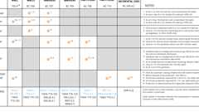Primary
Door Fire Ratings in Protective Wall Assemblies
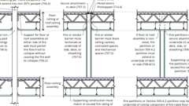
Fire & Smoke: Walls vs. Barriers vs. Partitions
509.4.2.1 Protection Limitation
Diagram
Where an automatic sprinkler system is provided in accordance with Table 509.1, only the space occupied by the incidental use need be equipped with such a system.
UpCodes Diagram (1)
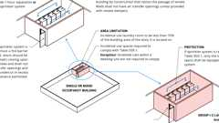Primary
Incidental Uses: Laundry Rooms
Section 510 Special Provisions
Diagram
UpCodes Diagrams (5)
Open Parking Garage Beneath Groups A, I, B, M and R
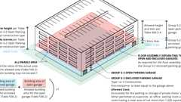
Group S-2 Enclosed Parking Garage With Group S-2 Open Parking Garage Above
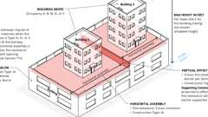
Vertical Offsets in Podium Horizontal Assemblies
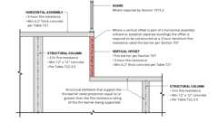
Vertical Offsets in Podium Horizontal Assemblies - Cross Section
Group B or M Buildings With Group S-2 Open Parking Garage Above
510.1 General
Diagram
The provisions in Sections 510.2 through 510.9 shall permit the use of special conditions that are exempt from, or modify, the specific requirements of this chapter regarding the allowable building heights and areas of buildings based on the occupancy classification and type of construction, provided the special condition complies with the provisions specified in this section for such condition and other applicable requirements of this code. The provisions of Sections 510.2 through 510.8 are to be considered independent and separate from each other.
UpCodes Diagram (1)
Building Height Measurements
510.2 Horizontal Building Separation Allowance
Assembly
Diagram
A building shall be considered as separate and distinct buildings for the purpose of determining area limitations, continuity of fire walls, limitation of number of stories and type of construction where the following conditions are met:
- The buildings are separated with a horizontal assembly having a fire-resistance rating of not less than 3 hours. Where a horizontal assembly contains vertical offsets, the vertical offset shall be constructed as a fire barrier in accordance with Section 707 and shall have a fire-resistance rating of not less than 3 hours.
- The building below, including the horizontal assembly and any associated vertical offsets, is of Type IA construction.
- Shaft, stairway, ramp and escalator enclosures through the horizontal assembly shall have not less than a 2-hour fire-resistance rating with opening protectives in accordance with Section 716.
Exception: Where the enclosure walls below the horizontal assembly have not less than a 3-hour fire-resistance rating with opening protectives in accordance with Section 716, the enclosure walls extending above the horizontal assembly shall be permitted to have a 1-hour fire-resistance rating, provided that the following conditions are met:
  - The building above the horizontal assembly is not required to be of Type I construction.
  - The enclosure connects fewer than four stories.
  - The enclosure opening protectives above the horizontal assembly have a fire protection rating of not less than 1 hour.
- Interior exit stairways located within the Type IA building are permitted to be of combustible materials where the following requirements are met:
  - The building above the Type IA building is of Type III, IV, or V construction.
  - The stairway located in the Type IA building is enclosed by 3-hour fire-resistance-rated construction with opening protectives in accordance with Section 716.
- The building or buildings above the horizontal assembly shall be Group A, B, M, R or S occupancies.
- The building below the horizontal assembly shall be protected throughout by an approved automatic sprinkler system in accordance with Section 903.3.1.1, and shall be permitted to be any occupancy allowed by this code except Group H.
- The maximum building height in feet (mm) shall not exceed the limits set forth in Section 504.3 for the building having the smaller allowable height as measured from the grade plane.
UpCodes Diagrams (5)
Primary
Vertical Offsets in Podium Horizontal Assemblies - Cross Section
Primary
Vertical Offsets in Podium Horizontal Assemblies
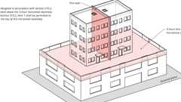
Fire Walls: Vertical Continuity - Exception 5
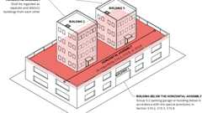
Multiple Buildings Above a Horizontal Assembly
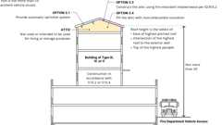
Attic Fire Protection: Condition 3
Assemblies (4)
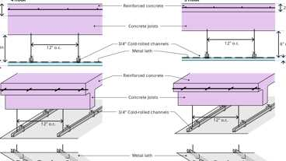
5-1.1: 3hr & 4hr, Reinforced conc.
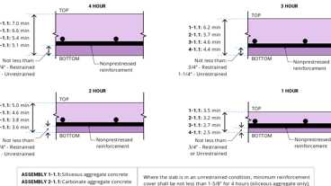
1-1.1 Through 4-1.1: Concrete Slab
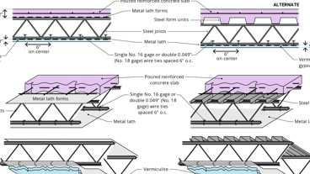
6-2.1: 3hr Steel
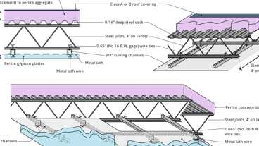
17-1.1: 3hr, Steel/Conc.
Building products (2)
FOAMULAR® NGX® 400/600/1000
Owens Corning

FOAMULAR® NGX® 404RB/604RB
Owens Corning

510.3 Group S-2 Enclosed Parking Garage With Group S-2 Open Parking Garage Above
Diagram
A Group S-2 enclosed parking garage with not more than one story above grade plane and located below a Group S-2 open parking garage shall be classified as a separate and distinct building for the purpose of determining the type of construction where the following conditions are met:
- The allowable area of the building shall be such that the sum of the ratios of the actual area divided by the allowable area for each separate occupancy shall not exceed 1.
- The Group S-2 enclosed parking garage is of Type I or II construction and is at least equal to the fire-resistance requirements of the Group S-2 open parking garage.
- The height and the number of tiers of the Group S-2 open parking garage shall be limited as specified in Table 406.5.4.
- The floor assembly separating the Group S-2 enclosed parking garage and Group S-2 open parking garage shall be protected as required for the floor assembly of the Group S-2 enclosed parking garage. Openings between the Group S-2 enclosed parking garage and Group S-2 open parking garage, except exit openings, shall not be required to be protected.
- The Group S-2 enclosed parking garage is used exclusively for the parking or storage of private motor vehicles, but shall be permitted to contain an office, waiting room and toilet room having a total area of not more than 1,000 square feet (93 m²) and mechanical equipment rooms associated with the operation of the building.
UpCodes Diagrams (5)
Primary
Group S-2 Enclosed Parking Garage With Group S-2 Open Parking Garage Above
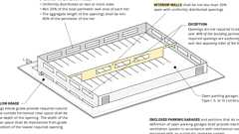
Open Parking Garage
Multiple Buildings Above a Horizontal Assembly
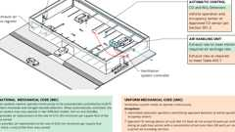
Enclosed Parking Garage Ventilation - Ducted System
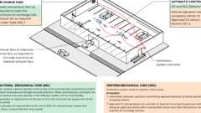
Enclosed Parking Garage Ventilation - Ductless Jet-Induction System
510.4 Parking Beneath Group R
Diagram
Where a maximum one story above grade plane Group S-2 parking garage, enclosed or open, or combination thereof, of Type I construction or open of Type IV construction, with grade entrance, is provided under a building of Group R, the number of stories to be used in determining the minimum type of construction shall be measured from the floor above such a parking area. The floor assembly between the parking garage and the Group R above shall comply with the type of construction required for the parking garage and shall also provide a fire-resistance rating not less than the mixed occupancy separation required in Section 508.4.
UpCodes Diagrams (2)
Primary
Podiums: Parking Beneath Group R
Attic Fire Protection: Condition 3
510.5 Group R-1 and R-2 Buildings of Type IIIA Construction
Assembly
Diagram
For buildings of Type IIIA construction in Groups R-1 and R-2, the maximum allowable height in Table 504.3 shall be increased by 10 feet (3048 mm) and the maximum allowable number of stories in Table 504.4 shall be increased by one where the first-floor assembly above the basement has a fire-resistance rating of not less than 3 hours and the floor area is subdivided by 2-hour fire-resistance-rated fire walls into areas of not more than 3,000 square feet (279 m²).
UpCodes Diagrams (3)
Primary
Podiums: Type IIIA Height Increase (2021)
Fire Walls and Party Walls
Type IIIA Construction
Assemblies (3)
6-2.1: 3hr Steel
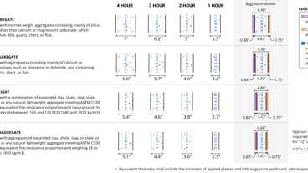
4-1.1: Concrete Walls
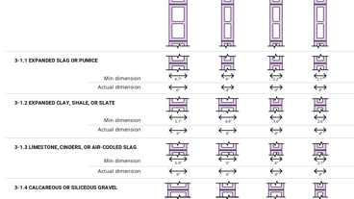
3-1.1 thru 3-1.4: CMU walls
510.6 Group R-1 and R-2 Buildings of Type IIA Construction
Assembly
Diagram
The height limitation for buildings of Type IIA construction in Groups R-1 and R-2 shall be increased to nine stories and 100 feet (30 480 mm) where the building is separated by not less than 50 feet (15 240 mm) from any other building on the lot and from lot lines, the exits are segregated in an area enclosed by a 2-hour fire-resistance-rated fire wall and the first floor assembly has a fire-resistance rating of not less than 1¹/₂ hours.
UpCodes Diagrams (4)
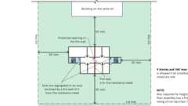Primary
Group R-1 & R-2 Bldgs Type IIA - Height Increase Pt 2
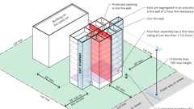Primary
Group R-1 & R-2 Bldgs Type IIA - Height Increase Pt 1
Fire Walls and Party Walls
Type IIA Construction
Assemblies (2)
4-1.1: Concrete Walls
3-1.1 thru 3-1.4: CMU walls
510.7 Open Parking Garage Beneath Groups A, I, B, M and R
Diagram
Open parking garages constructed under Groups A, I, B, M and R shall not exceed the height and area limitations permitted under Section 406.5. The height and area of the portion of the building above the open parking garage shall not exceed the limitations in Section 503 for the upper occupancy. The height, in both feet and stories, of the portion of the building above the open parking garage shall be measured from grade plane and shall include both the open parking garage and the portion of the building above the parking garage.
UpCodes Diagrams (2)
Primary
Open Parking Garage Beneath Groups A, I, B, M and R
Open Parking Garage
510.7.1 Fire Separation
Fire barriers constructed in accordance with Section 707 or horizontal assemblies constructed in accordance with Section 711 between the parking occupancy and the upper occupancy shall correspond to the required fire-resistance rating prescribed in Table 508.4 for the uses involved. The type of construction shall apply to each occupancy individually, except that structural members, including main bracing within the open parking structure, which is necessary to support the upper occupancy, shall be protected with the more restrictive fire-resistance-rated assemblies of the groups involved as shown in Table 601. Means of egress for the upper occupancy shall conform to Chapter 10 and shall be separated from the parking occupancy by fire barriers having not less than a 2-hour fire-resistance rating as required by Section 707 with self-closing doors complying with Section 716 or horizontal assemblies having not less than a 2-hour fire-resistance rating as required by Section 711, with self-closing doors complying with Section 716. Means of egress from the open parking garage shall comply with Section 406.5.
510.8 Group B or M Buildings With Group S-2 Open Parking Garage Above
Diagram
Group B or M occupancies located below a Group S-2 open parking garage of a lesser type of construction shall be considered as a separate and distinct building from the Group S-2 open parking garage for the purpose of determining the type of construction where the following conditions are met:
- The buildings are separated with a horizontal assembly having a fire-resistance rating of not less than 2 hours.
- The occupancies in the building below the horizontal assembly are limited to Groups B and M.
- The occupancy above the horizontal assembly is limited to a Group S-2 open parking garage.
- The building below the horizontal assembly is of Type IA construction.
Exception: The building below the horizontal assembly shall be permitted to be of Type IB or II construction, but not less than the type of construction required for the Group S-2 open parking garage above, where the building below is not greater than one story in height above grade plane.
- The height and area of the building below the horizontal assembly does not exceed the limits set forth in Section 503.
- The height and area of the Group S-2 open parking garage does not exceed the limits set forth in Section 406.5. The height, in both feet and stories, of the Group S-2 open parking garage shall be measured from grade plane and shall include the building below the horizontal assembly.
- Exits serving the Group S-2 open parking garage shall discharge at grade with direct and unobstructed access to a street or public way and are separated from the building below the horizontal assembly by 2-hour fire barriers constructed in accordance with Section 707 or 2-hour horizontal assemblies constructed in accordance with Section 711, or both.
UpCodes Diagrams (3)
Primary
Group B or M Buildings With Group S-2 Open Parking Garage Above
Open Parking Garage
Multiple Buildings Above a Horizontal Assembly
510.9 Multiple Buildings Above a Horizontal Assembly
Diagram
Where two or more buildings are provided above the horizontal assembly separating a Group S-2 parking garage or building below from the buildings above in accordance with the special provisions in Section 510.2, 510.3 or 510.8, the buildings above the horizontal assembly shall be regarded as separate and distinct buildings from each other and shall comply with all other provisions of this code as applicable to each separate and distinct building.
UpCodes Diagram (1)
Primary
Multiple Buildings Above a Horizontal Assembly

